Kester Sheridan (MSc Arts Computing)

Version 1

Arts Computing

Project Proposal

Table of Contents
1. Introduction 3
2. Project 1 – TV Doodle 9
3. Project 2 – Re-contextualising Subtitles 12
4. Project 3 – Moving Image as Collage 14
5. Aleatoric Alterpiece 17
6. Main Project 2 – ‘Quick, Quick, Slow’ 22
7. Technical Overview 23
7.1 Doodle TV 24
7.2 Re-contextualised Subtitles 25
7.3 Moving Image as Collage 25
8. Useful References 26

Introduction
Computer Art is still marginalised. It has yet to be accepted by a wider audience. Often the work is developed by computer scientist where imagery is secondary to the process. There is also an element of the mundane as it is often displayed in galleries on standard computer screens similar to an office environment. In the course of this introduction, I will show that these restrictions no longer apply and that freed from the shackles of hardware, computer art may become accepted by the wider gallery-going public as film as now been accepted through the works of Gillian Wearing, Steve McQueen etc.
There is an interesting trend developing in terms of technology. There is the convergence of computing with TV and Video technologies. Modern graphics cards for computers often now come with TV-out features. This is usually an S-video type jack designed to send a high-quality signal to a TV (see figure 1). This allows computers to use conventional televisions for their display (described by Microsoft as the 10-foot experience) whereas previously they were restricted only to specifically designed monitors (the 2-foot experience). If one considers also the recent developments in TV technology, this takes on a greater significance for the computer artist.
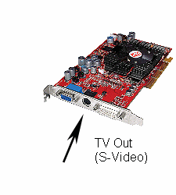
Figure 1: ATI Radeon Graphics card showing TV Out
In a move that seems similar to the arms race, the various manufacturers of LCD and Plasma TVs are determined to out do each other by bring out the world largest TV. Sharp is currently winning the LCD race with a 65inch TV and Panasonic are winning the plasma race with a TV of the same dimensions. These are comparable sizes to quite large canvases similar to those seen in art galleries, for example Botticelli’s Venus and Mars that can be seen in the National Gallery in London is 68 inches in length (see figure 2).

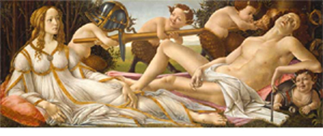
Figure 2: Venus and Mars about 1485, BOTTICELLI, Sandro, Egg tempera and oil on poplar 69.2 x 173.4 cm.
In a strange quirk of history, these large LCD and plasma screens are now beginning to adopt a similar position in the houses of the wealthy that once art held, namely above the fireplace and also as a status symbol. Figure 3 shows the Oval Drawing Room at Wallace Collection, London. The room recreates a drawing room of an eighteenth-century aristocrat. It is full of late eighteenth-century French furniture, sculpture and paintings with a large painting hanging above the fireplace. Contrast this with figures 4 and 5 the painting above the fireplace has now been replaced in the modern drawing room by a large digital widescreen plasma or LCD television. The prices are also comparable with modern plasma TVs costing around £3500 and a modern painting by a reasonable established artist costing a similar amount (see figures 6 and 7).

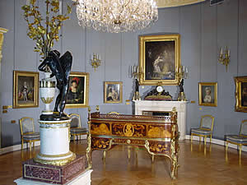
Figure 3: Oval Drawing Room at Wallace Collection, London
In another quirk of history, the electrical manufacturer Philips now produces a range of plasma screens that are disguised as mirrors (see figure 8). This seemingly takes the story full-circle with there also being a tradition for mirrors above fireplaces from the 18th and 19th centuries along with oil paintings. Consequently it is not inconceivable to imagine there being similar opportunity for art to regain the position above the fireplace through the use of computer art displayed on a plasma or LCD TV. This idea is made even more plausible by Microsoft’s development of ‘Windows Media Center’, which blurs the line between the TV and computer.

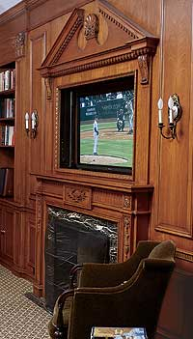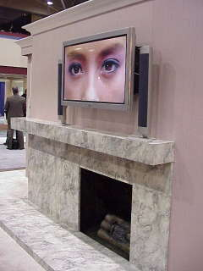
Figures 4 and 5: Widescreen televisions in the modern drawing room

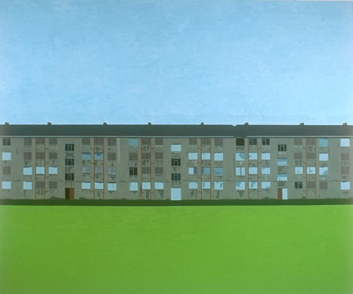
Figure 6: 'Drumchapel, Glasgow', 2003 Tony McCorry Oil on canvas 84" x 70", £3500 available on Britart.com (3/05/05)

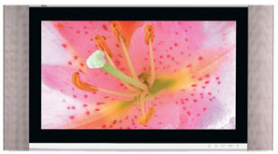
Figure 7: Sony Plasma Digital 42 Inch Widescreen Television, £3,495.00 available at JohnLewis.com

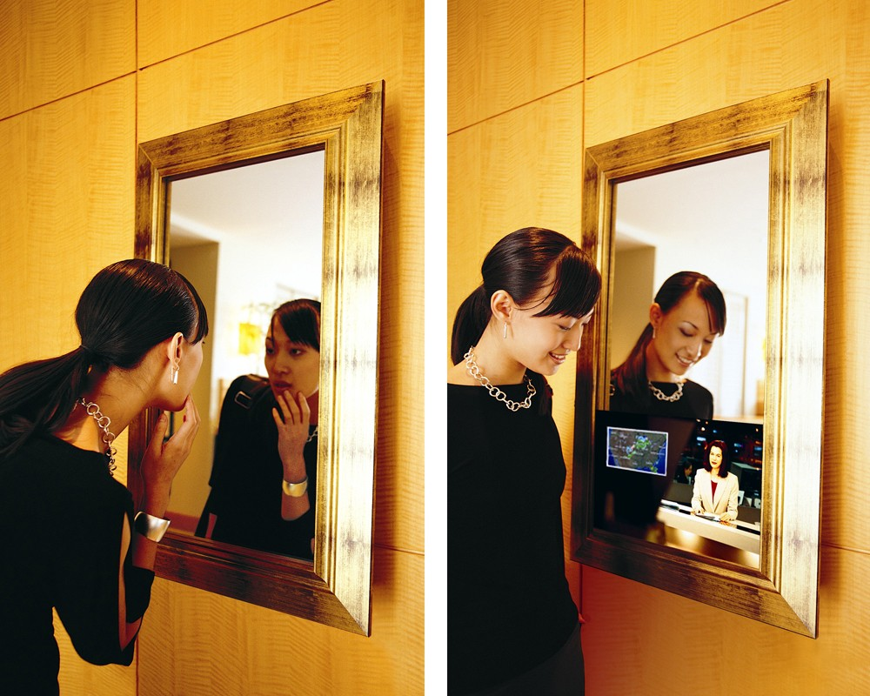
Figure 8: The Mirror Plasma TV – turned off (left), turned on (right)
Microsoft through the development of Windows Media Center has packaged the various capabilities of the home computer such as CD and DVD watching and recording, TV watching via a TV capture card (see figure 9) into one user interface for media entertainment (see figure 10).
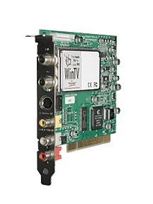
Figure 9: Hauppauge WinTV-PVR-150MCE TV capture card is a TV and FM radio tuner.

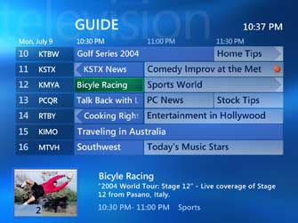
Figure 10: Screenshot from Windows XP Media Center Edition 2005
Windows XP Media Center Edition 2005 allows for such functionality as viewing upcoming TV programs via an electronic program guide (see figure 10) and the ability to record TV programs to watch later. It also provides novel user interaction devices such the remote control (see figure 11) to further blur the boundaries between TV and computing.
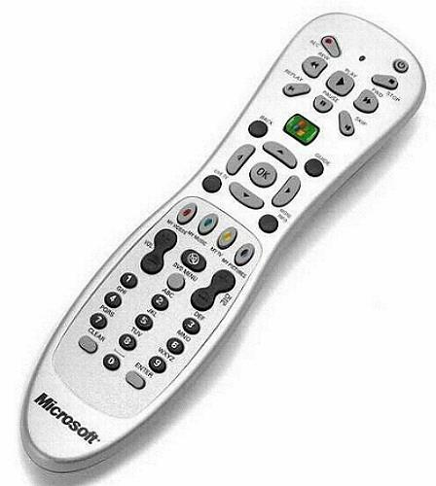
Figure 11: Microsoft Windows Media Center remote control
It is my project proposal to utilize such technologies for the purposes of making art. The use of the TV tuner card I believe holds great potential for making challenging and interesting art. Unlike most conventional art mediums such as painting, sculpture and video where the content remains essential static fixed at the time of its creation by the artist, using TV or radio as input which itself is in constant flux, no one day’s schedule is the same as the previous then in turn the art piece is also constantly changing. For the spectator this means that potentially each time they visit the artwork they may be presented with a different experience unlike visiting a video installation or painting that does not change.
As one cannot determine what is likely to appear on TV this introduces an element of chance. This taps into a long tradition of artists who have embraced randomness and chance in their work such as the Abstract painter, Jackson Pollock and Dada artist Jean Arp who made collages by dropping small pieces of paper onto a larger piece, then adhering them to where they landed (see figure 11). As the pieces I hope to develop use recognisable imagery from the TV it is also hoped that purely by accident, ‘happy accidents’ may occur whereby meaning maybe derived by the spectator.

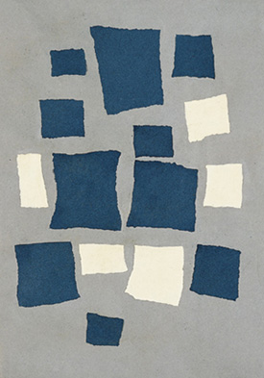
Figure 11: Jean (Hans) Arp, Collage Arranged According to the Laws of Chance, 1916–17
Torn-and-pasted papers on grey paper, 19 1/8 x 13 5/8" (48.6 x 34.6 cm)
I would like to develop the project to exhibit by June 21st for the opening of the Ben Pimlott Building, Goldsmiths. I have broken the project down into three smaller works. If I am unable to finish all three sections hence the full project, then these pieces are able to stand-alone in their own right.

Project 1 – TV Doodle
Often the students have drawn on the pictures in school textbooks. Such childish things as glasses, willies, tits, and Hitler moustaches have been added to these images. I propose to develop an application that automatically draws such props on to live TV images. I think a channel like BBC 24, a 24-hour news channel would be a particularly appropriate TV channel to use as news has a certain gravitas but it is difficult to take something serious when there is pair of comedy glasses or moustache drawn on the newscaster (see figure 12). From a technical point of view using a news channel, it may also be easier to find the face, as the newscaster is usually two-thirds view so the face is roughly in the same place each time. There is also the opportunity for ‘happy accidents’ to occur such as if the computer was to draw a Hitler moustache on George Bush then the spectator may read this as a political statement but the computer has no comprehension of who George Bush is so this would happen purely by chance. There is also a dichotomy as the doodle in real-life is such a low-tech thing whereas on the computer it becomes a high tech thing requiring face detection etc.

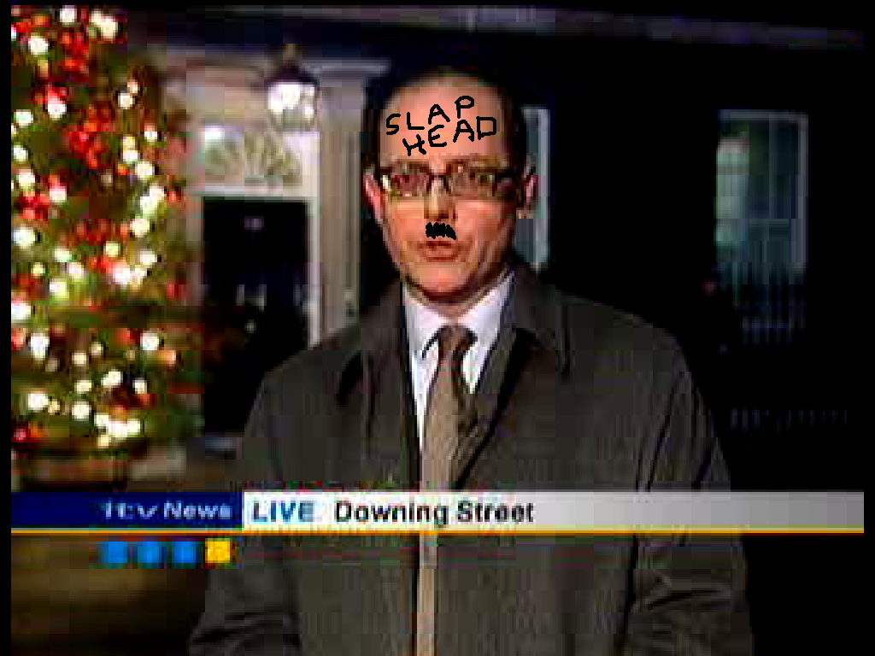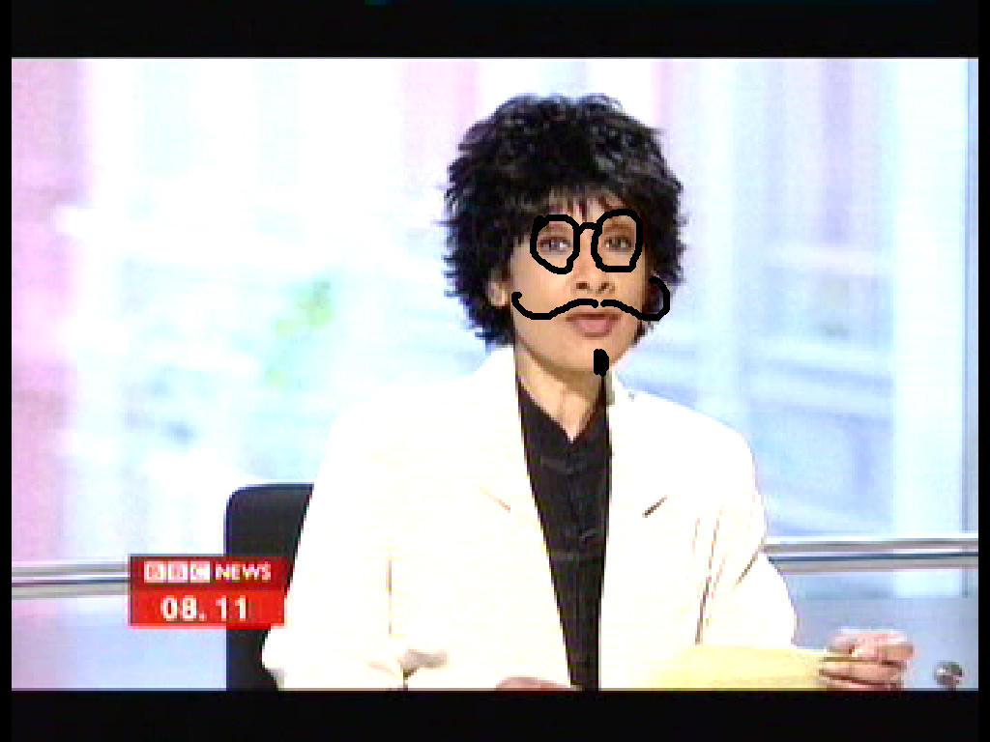
Figure 12: A mock-up of how the TV Doodle application may look
Although this imagery sounds childish it taps into a long tradition in art of defacing other work. The most well known act of degrading a famous work of art is probably Marcel Duchamp's L.H.O.O.Q., a cheap postcard-sized reproduction of the Mona Lisa upon which in 1919 the artist drew a moustache and a thin goatee beard (see figure 13). On one hand L.H.O.O.Q. must be understood as one of Duchamp's "readymade" works of art -- works that he didn't make, but which, by having been placed intellectually within a conceptual framework of "Art," he forces the observer to see ordinary objects from new perspectives. In this way their innate aesthetic contents would make themselves manifest. However, to most observers, instead of elevating the ordinary, Marcel's Mona Lisa works in the opposite direction; it defaces (literally) that which has been cherished, and brings a famous work down to the level of vulgar vandalism and cheap reproduction. The title makes the point, too, but obscurely, since when pronounced in French "L.H.O.O.Q." reports as a pun on the phrase "Elle a chaud au cul," which translates colloquially as "She is hot in the ass."

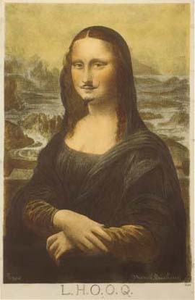
Figure 13: Postcard of Replica of L.H.O.O.Q. (1919), Marcel Duchamp, Collotype, hand-coloured with watercolour.
A modern example of this can be found in the work of Jake and Dinos Chapman’s ‘Insult to Injury’ (2003) in which a set of Goya's Disasters of War etchings is defaced (see figures 14 and 15). The artists have systematically gone through the entire 80 etchings and changed all the visible victims' heads to clowns' heads and puppies' heads.
"Goya represents that kind of expressionistic struggle of the Enlightenment with the ancién regime," says Jake, "so it's kind of nice to kick its underbelly. Because he has a predilection for violence under the aegis of a moral framework. There's so much pleasure in his work. To produce the law, one has to transgress it. Not to be too glib in the current conditions, but there's something quite interesting in the fact that the war of the Peninsula saw Napoleonic forces bringing rationality and enlightenment to a region that was presumed Catholic and marked by superstition and irrationality. And here's Goya, who's very cut free from the Church, who embodies this autonomous enlightened being, embodied as a gelatinous dead mass without redemption - then you hear George Bush and Tony Blair talking about democracy as though it has some kind of natural harmony with nature, as though it's not an ideology."
The Chapmans have recognized in the Disasters of War a template for their own nightmares. This work also references the American artist Robert Rauschenberg in 1950’s erasing a drawing by Willem de Kooning, the great abstract expressionist painter. However in this case he sought the older artist's permission, of course impossible in this case
The altered prints make you think a serial killer with an addiction to drawing psychotic clown faces has got into the British Museum's prints and drawings room - like the killer in Red Dragon who eats an original Blake.
Violet and white bursts of colour, the clown heads and puppy faces are astonishingly horrible. They are given life, personality, by some very acute drawing, and so it's not a collision but collaboration, an assimilation, as they really do seem to belong in the pictures - one art historical antecedent is Max Ernst's collages in which 19th-century lithographs are reorganised into a convincing dream world. What the Chapmans have released is something nasty, psychotic and value-free; not so much a travesty of Goya as an extension of his despair. What they share with him is the most primitive and archaic and Catholic pessimism of his art - the sense not just of irrationality but something more tangible and diabolic.

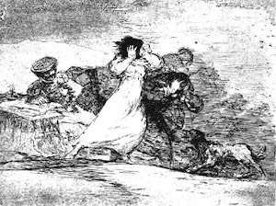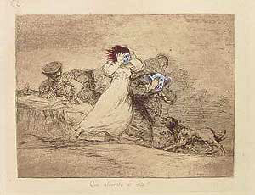
Figure 14: Francisco Goya, Etching from Disasters of War Figure 15: Jake and Dinos Chapman, Insult to Injury (2003)

Project 2 – Re-contextualising Subtitles
Without audio on the television and with the subtitles on, there is a reliance on the subtitles to aid the understanding, meaning and context of the images being shown on the screen, however if these subtitles have no relation to images on the screen then the images are re-contextualised and consequently their meaning is changed.
The second project is to show the images from a TV channel but add my own subtitles. Figure 16 shows how an image context can be changed.

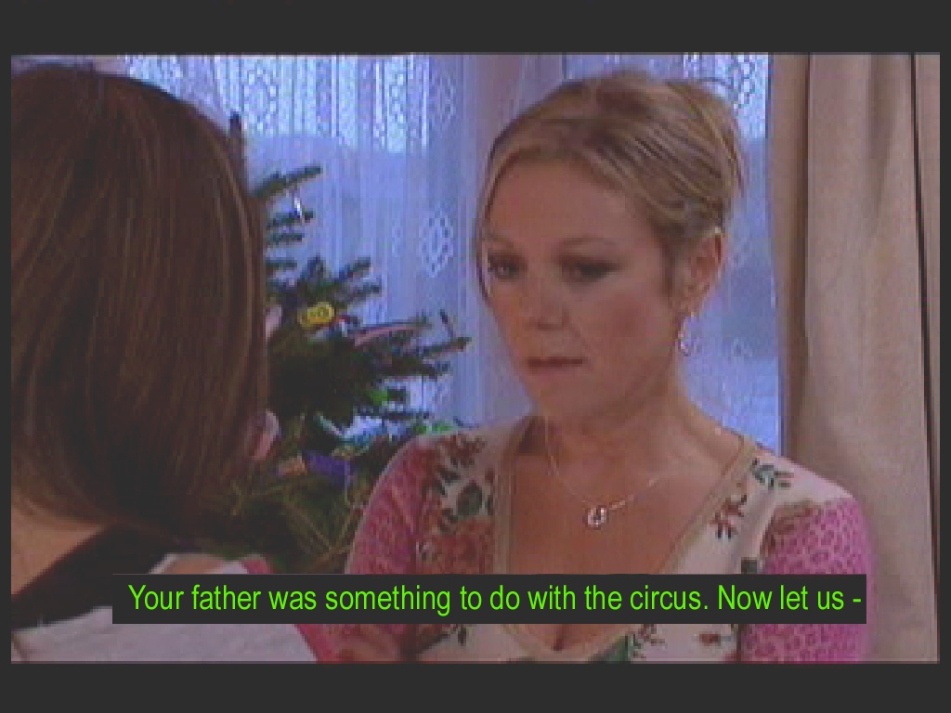
Figure 16: Mock-up of a screen with an image from the TV soap Hollyoaks and subtitles from a Peter Cook sketch
The Passion of Christ was a highly emotive movie directed by Mel Gibson (see figure 17). It is claimed to be the most accurate and realistic adaptation of the story of Jesus Christ. The actors speak Aramaic throughout so English subtitles have been added although Mel Gibson originally wanted the film to be released without them but changed his mind at the last stage. It is now considered by many that there are now too many subtitles in the film. With this as background I thought it would be interesting to use these subtitles by placing them over live TV. Without the associated images much of the power of the film is lost if it is told only through the subtitles. There is like the previous project a chance that the spectator may draw some unexpected meaning from associating the images with the text. This would once again be purely random, as one does not know what images are going to be shown on TV.
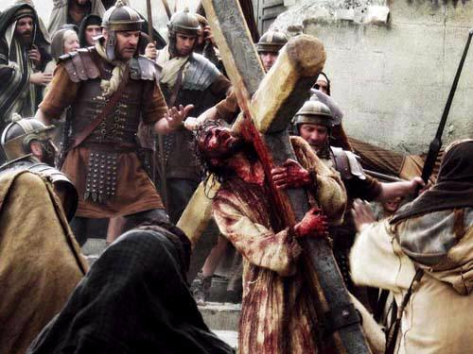
Figure 17: Scene from The Passion of the Christ (2004) directed by Mel Gibson

Project 3 – Moving Image as Collage
There is currently a trend for artists to use collage in their work. This can be seen in the works of in-vogue artists such as Christian Marclay (see figure 18) and Wangchi Mutu (see figure 19). Such artists generally use static images as the elements of their collage, in Marclay case the elements are record covers in his Body Mix series and Mutu uses pictures cut from fashion magazines.
Figure 18: ’Footstompin', from the Body Mix series, 1999. Christian Marclay, Record album covers and thread.
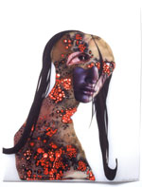
Figure 19: Untitled (Classic Profile Series) 2003, Wangechi Mutu, Ink, collage on mylar

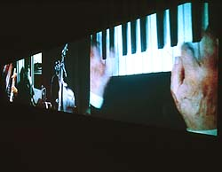
Figure 20: Video Quartet (2002), Christian Marclay
In Marclay’s piece Video Quartet (see figure 20), the spectator is seated in a dark viewing room and treated to nearly 700 film clips edited together to form a single blend of music and visuals projected, at times confusingly, onto four large, adjacent screens. Alternating between harmonious and discordant, it comprises 14 minutes and 32 seconds of mostly powerful Hollywood moments. In this piece the film clips are brought together as a collage. In all three cases the works remain static as they do not change over time.
It is my intention to create a collage of moving images. By using the TV input as source the collage is ever changing just as TV is ever changing. The simplest form of collage is to position the different channels in arrangement similar to that of figure 21. I may also adopt a further visual effect by overlaying a image of the top of the TV panels with transperencies in form of shapes where the TV channels below become visible.
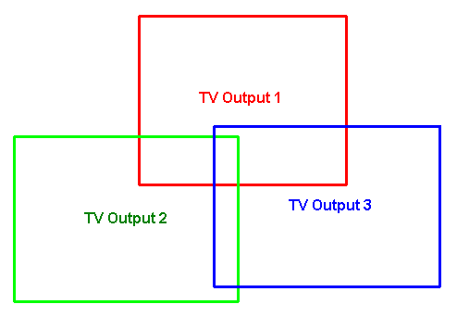
Figure 21: Potential layout for moving image collage
The experience of this visual collage would be further heightened by playing all the sounds of all the TV channels at once so a cacophony of sound is produced. Through this cacophony, the odd word may become audible, which may also lead to chance phrases being heard which may be read as meaning by the spectator. This means that the spectator can get a very different experience each time they visit the piece due the randomness of it. Such an effect would require multiple TV cards in the same machine, one for each channel.

Aleatoric Alterpiece
Bringing these three previous projects together, I propose to create a piece of work entitled ‘Aleatoric Alterpiece’. Aleatory (or aleatoric) means, "pertaining to luck", and derives from the Latin word alea, the rolling die. Aleatoric art is that which exploits the principle of randomness. Most ambitious of these is Raymond Queneau's Cent Mille Milliards de Poèmes. Queneau created the work in 1960, by creating 10 possible options for each line of a sonnet. Each line is selected randomly, creating an almost perpetually novel poem. The idea relates somewhat to the Surrealist game of Exquisite Corpse, in which one person draws the top of a figure, then folds the paper only a small portion is revealed to the next person, who draws the middle portion, and so on.
‘Aleatoric Alterpiece’ is inspired by the numerous occasions in history where people have found spiritual and religious significance due to freak occurrences in nature that have produced imagery which they believe is of religious icons like a picture of Jesus. For example in April 2005 hundreds of people flocked to a motorway underpass in the US city of Chicago to view a salt stain on a concrete wall many say is an image of the Virgin Mary (see figure 22).

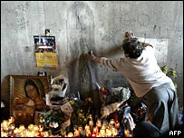
Figure 22: A salt stain in US motorway underpass in Chicago said to bear the image of the Virgin Mary
Also in 2005, a decade-old toasted cheese sandwich said to bear an image of the Virgin Mary was sold on the eBay auction website for $28,000 (see figure 23). The sandwich had never gone mouldy since it was made 10 years ago even though no effort was made to preserve it. By the time the sandwich auction closed, the sale had received over 1.7 million hits on the auction site. Possibly spurred on by the success of this sale, a bar manager in Switzerland has recently announced plans to sell an oyster shell resembling the face of Jesus Christ (see figure 24).

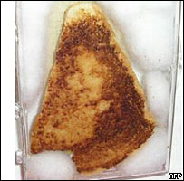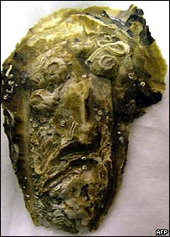
Figure 23: Toasted cheese sandwich bought for $28,000 Figure 24: Oyster shell resembling the face of Jesus Christ
In all of these cases, the imagery was generated by pure chance, which I think would be something interesting to explore through this piece of work. Using TV as the source which is for our purposes a random input as we can not govern what will appear on the screen, one is just as likely to find something spiritual significant in the work as one would when toasting a cheese sandwich.
Through the work it is also possible to explore the role that TV and computers now play in our society. For some people they have now seemingly replaced religion. We all put our faith in technology with the plane’s auto pilot, computer banking systems etc. Compare the figures for Church attendances in 2005 with the fact that the TV soap opera ‘Coronation Street’ in February 2003 for one double episode received over 17 million viewers or that at the beginning of March 2005, the new Nintendo DS hand-held games console sold 87,000 units in the first two days, and one can see that media is seemingly more important than religion.

Total Church Attendance in Great Britain 1980-2005
Great Britain | 1980 | 1985 | 1990 | 1995 | 2000 | 2005
Total | 6,021,600 | 5,643,200 | 5,371,700 | 4,797,400 | 4,379,900 | 4,016,400
% of population | 11.0 | 10.2 | 9.6 | 8.5 | 7.7 | 7.0
Table 1: Total Church Attendance in Great Britain 1980-2005 (taken from http://www.christian-research.org.uk/ans_1.htm)
This analogy of technology being a new religion is further backed up by the fact that several computer book publishers have adopted the word ‘bible’ as a marketing ploy. It describes a detailed and sometimes authoritative reference book covering a particular operating system, platform, or application (see figure 25).

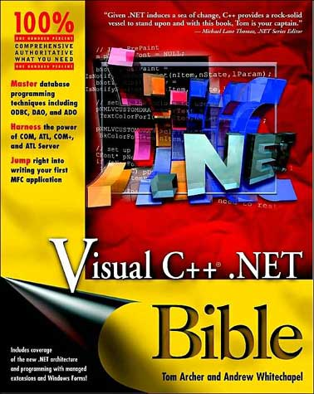
Figure 25: An authoritative computer reference book described as a Bible
The British artist Richard Hamilton in1987 participated in a BBC TV programme entitled "Painting with light". In the programme, Hamilton recreates a previous piece of work he made using more conventional means, by using the Quantel Paintbox (see figure 26). At the time the Quantel Paintbox was a state of the art computer graphics package. The word light is often referred to in terms of spirituality, for example Holman Hunt names his painting of Jesus, ‘the Light of the World’ (see figure 27). The resurrection of Jesus is often shown as a great light.

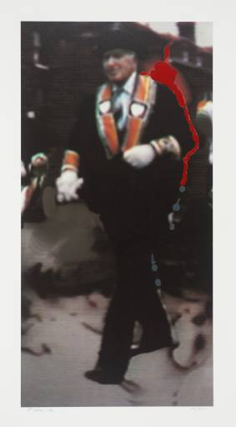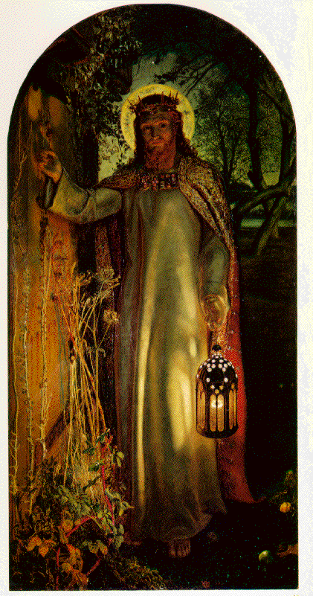
Figure 26: The Orangeman (1990), Richard Hamilton Figure 27: The Light of the World (1851-53), William Holman Hunt
In a conventional altarpiece, the work usually, such as in the case of the Isenheim Altarpiece (see figure 27) consists of 3 panels and a predella at the bottom. The ‘Aleatoric Alterpiece’ will consist of three virtual panels on the widescreen display (see figure 28). The left panel will take the form of the TV doodle piece; one might see this as related to the mocking of Christ, or the mocking of media in this case. The right panel will consist of the subtitle piece using the subtitles of the ‘Passion of the Christ’. The middle panel is based around TV as a collage possibly using the image show in figure 29a as the overlay to the collage. The white space in the image is transparent so that the TV collage is visible behind.

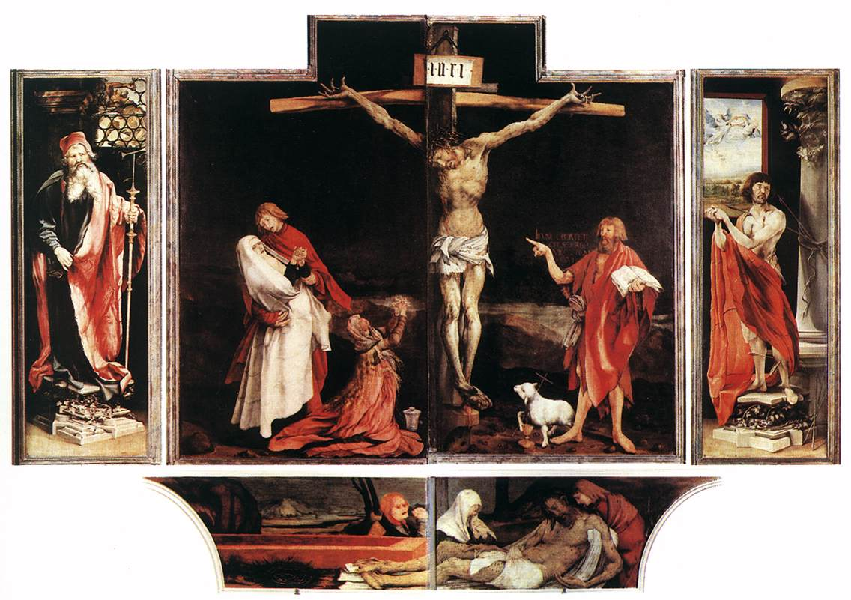
Figure 27: Isenheim Altarpiece (c. 1515), oil on wood, Musée d'Unterlinden, Colmar
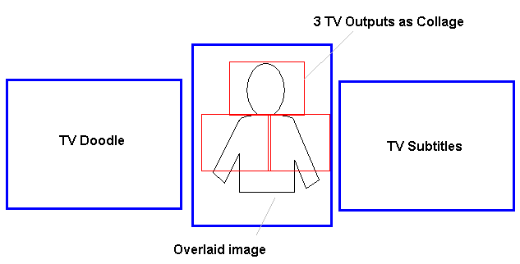
Figure 28: Potential layout for Aleatoric Alterpiece

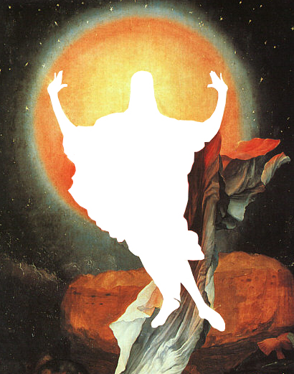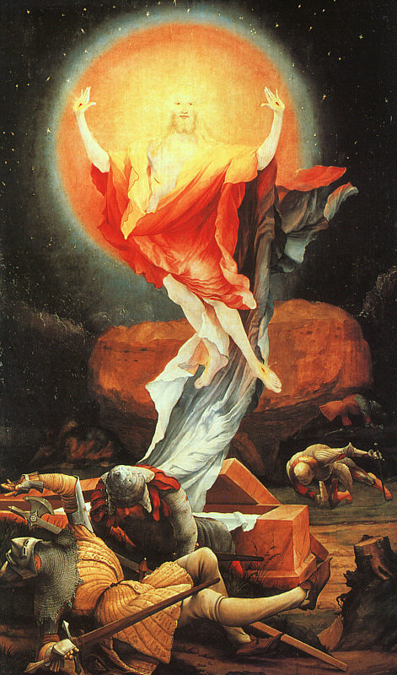
Figure 29a: Image with transparency for overlay Figure 29b: The Isenheimer Altarpiece, The Resurrection of Christ
Figure 30 shows how the ‘Alterpiece’ would be installed in a gallery. To continue the similarity between the piece and a more conventional religious altarpiece, a plinth or altar on which the computer bible as shown in figure 25 would be placed in front of the widescreen display. The plinth would also allow the computer to be hidden beneath.
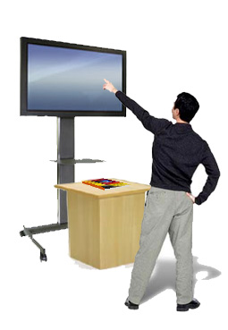
Figure 30: Mock-up of installation of the ‘Aleatoric Alterpiece’ with plinth and computer ‘bible’

Main Project 2 – ‘Quick, Quick, Slow’
Using the TV capture card again, I thought it would be interesting to explore peoples’ perception of time and memory. The recall of past memories triggered by a Madeleine biscuit is a feature of the book ‘In Search of Lost Time’ by Marcel Proust. In the piece entitled ‘Quick, Quick, Slow’ with the name making reference to a rhythm commonly used in dance and life often seen as a dance (see figure 31), the spectator is confronted by a TV moving image that is constantly in a state of flux either slowing or speeding up. This will be a recorded clip from TV, recorded 30 minutes previously and 30 minutes in duration. This clip is effectively memory being in the past. By playing the clip at different rates, it is similar to our own perception of memory where certain things seem more vivid that others, for instance if we meet someone from our past than it seems the past is catching up with the present. However this obviously cannot happen, and is also the case in the piece that although the clip is speeded up and slowed down overall it is still only 30 minutes hence the past remains the past. It also makes reference to people’s perception of time as people often say that ‘time flies by when you are having fun’ or ‘time is dragging’.

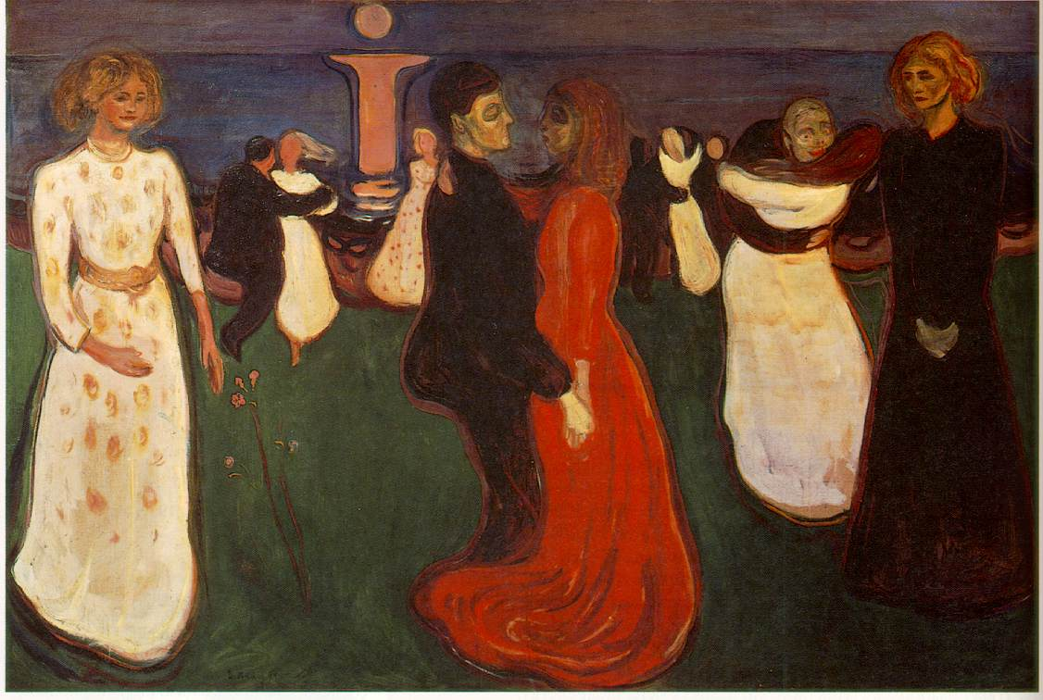
Figure 31: The Dance of Life by Edvard Munch
Once the clip is finished then the next recorded clip will be played that was recorded whilst the previous one was playing and so the process is continuous like time itself. The previous clip is also deleted so like time one can never go back.

Technical Overview
When designing programmes with the potential of running on widescreen TV, it is important to take into account the aspect ratio (the width and height proportion of the display). Standard TV and computer monitor displays have an aspect ratio of 4:3 (meaning for every 4 pixels running along the width of the frame buffer there are 3 pixels along the height, sometimes also represented simply as 1.33). Widescreen TV (High definition TV) has an aspect ratio of 16:9. The three most common formats of TV are shown below:
- 480p EDTV (Enhanced Definition Television) - 480 scan lines presented progressively. This mode can output either 4:3 (with a frame buffer resolution of 640x480) or 16:9 (720x480).
- 720p HDTV - 720 scan lines presented progressively. This mode is always 16:9 (1280x720).
- 1080i HDTV - 1080 scan lines presented interlaced. This mode is always 16:9 (1920x1080, or 1920x540 if rendering the interlace fields separately).
It is important that any programme should be able to display images correctly without being stretched or cropped on all of these formats. It is also important to taken into account the displayable area on the TV. The entire image frame buffer may not be visible to the end user; often a certain amount of border pixels are covered by the display's front bezel. To ensure that critical UI elements are visible across the spectrum of potential consumer display hardware you should observe the "title-safe region" requirements for your target display mode: For non-HDTV modes, the title-safe region is the inner 85 percent of the frame buffer; for HDTV modes, the title-safe area is the inner 90 percent. Therefore it is best to keep within the inner 85 percent of the frame buffer.
Much of the projects covered in this proposal are based on the core technology of displaying images from a TV Capture card, this should also mean the turnaround should be quicker. I have decided to use the programming language C# as opposed to JAVA. JAVA provides the Java Media Framework for displaying media clips, which is built on top of DirectX in Windows. DirectX is a collection of application program interfaces (APIs) developed by Microsoft for the Windows operating systems to manipulate graphics, sound, input controllers, networking, and multimedia. With C#, it is possible to program directly using DirectX 8.0 or higher whereas JAVA has more limited functionality through the JMF which exposes some of the DirectX APIs. For instance I have been unable to change the TV channel via JAVA and the JMF whilst this is possible in C# and DirectX using DirectShow.
The drivers for many of these TV Capture cards seem only to have been commercially developed for the Windows environment so the advantages of portability that Java has do not apply in this case as the running of these TV cards under Linux is problematic.
Similar to JAVA there is an online community of C# developers who have developed applications in the open-source environment. It is my intention to use some of these applications and adapt them to suit my purposes.

Doodle TV
In this project I will take a snapshot of the TV periodically and then do face detection on this image. I will try adapting Frank Fleurey’s application for face detection at http://franck.fleurey.free.fr/FaceDetection/index.htm with downloadable source code. This software uses neural networks to find a face in an image, see figure 32 for more detailed information. When I trailed this application I have found it quite effective, but equally quite slow so I might need to change it so only searches a smaller portion of the screen image.

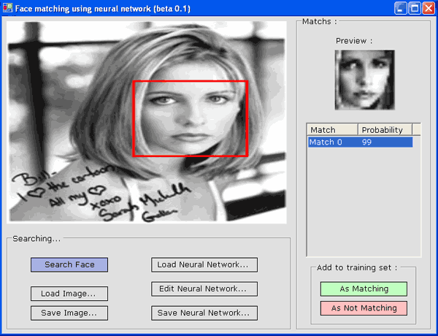
Figure 31: Screenshot of Face Matching using Neural Networks
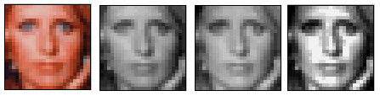
Figure 32a: Normalisation Filters – Converted to Greyscale, brightness (by a best fit linear filter), histogram equalized (to normalize contrast)
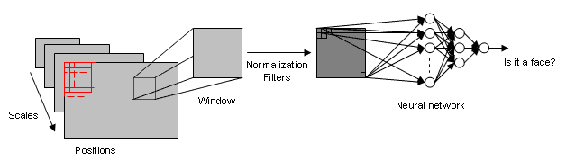Figure 32b: Process Diagram for ‘Face Matching using Neural Networks’ application
Once a position has been determined then a doodle image will be overlaid over this portion of the screen image.

Re-contextualised Subtitles
The subtitles for this piece will be read from a file so can be altered and then overlaid directly over the live TV image.

Moving Image as Collage
This will require a separate TV card for each TV image if they are to be showing different TV channels.

Useful References
This is a selection of useful resources on the Internet which I have yet to fully investigate.
General
http://www.zzz.com.ru/index.php?area=pages&action=view_page&page_id=11
http://www.gamedev.net/community/forums/topic.asp?topic_id=316482
Image Processing
http://www.codeproject.com/cs/media/Image_Processing_Lab.asp
http://www.thecodeproject.com/cs/media/displacementfilters.asp
http://www.codeproject.com/cs/media/CsTranspTutorial1.asp
DirectX Examples
http://www.thecodeproject.com/cs/media/directxcapture.asp
Motion Detection
http://www.thecodeproject.com/useritems/Motion_Detection.asp
DirectX - DirectShow
http://www.codeproject.com/cs/media/directshownet.asp
http://www.codeproject.com/cs/media/picturesfrommovie.asp
Face Detection
http://www.yov408.com/html/tutorials.php?s=121
http://franck.fleurey.free.fr/FaceDetection/index.htm
Skin Detection
http://www.codeproject.com/useritems/Skin_RecC_.asp
Overlying Text
http://www.codeproject.com/dotnet/vbtextoverlay.asp
Flicker-free Drawing
http://www.codeguru.com/Csharp/Csharp/cs_graphics/drawing/article.php/c6137/
JAVA – Java Media Framework
http://java.sun.com/products/java-media/jmf/2.1.1/samples/

Taken from http://msdn.microsoft.com/library/default.asp?url=/library/en-us/directx9_c/directx/TechnicalArticles/MCE.asp
Taken from http://www.i4u.com/article2217.html and http://www.i4u.com/article2071.html
Taken from http://www.flattv.philips.com/index.cfm?event=mirrortv
Taken from http://www.dartmouth.edu/~chance/course/student_projects/Kristin/Kristin.html and http://www.preoccupations.org/music/
Taken from http://www.studiolo.org/Mona/MONASV12.htm
http://www.guardian.co.uk/arts/features/story/0,11710,926134,00.html
http://www.killermovies.com/p/passion/articles/3226.html
http://www.24hourmuseum.org.uk/exh_txo_en/ART26670.html
Taken from http://www.artlex.com/ArtLex/a/aleatory.html
Taken from http://www-personal.umich.edu/~luriea/aboutpoems.html
Taken from http://news.bbc.co.uk/1/hi/world/americas/4468275.stm
Taken from http://news.bbc.co.uk/1/hi/world/americas/4034787.stm
Taken from http://news.bbc.co.uk/1/hi/world/europe/4172689.stm
http://news.bbc.co.uk/1/hi/entertainment/tv_and_radio/2796201.stm
http://specialreserve.co.uk/n_3405-news.html
www.netdictionary.com/b.html
Taken from http://msdn.microsoft.com/library/default.asp?url=/library/en-us/directx9_c/directx/TechnicalArticles/MCE.asp

