Kester Sheridan (MSc Arts Computing)

Version 2

Database Systems - CIS 209

Coursework 1

PART A - TASKS

- Create two databases then list them. Remove one database and keep the second one.

Commands:
Psql test
CREATE DATABASE database_1;
CREATE DATABASE database_2;
\l
DROP DATABASE database_2;
\q

OR FROM UNIX Command line

Createdb database_1
Createdb database_2

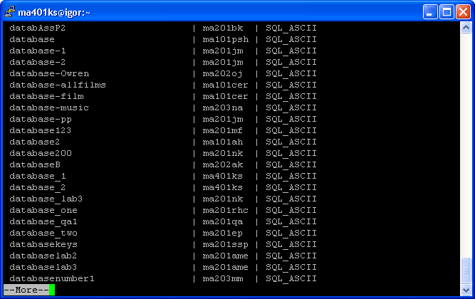

Then database_2 removed.

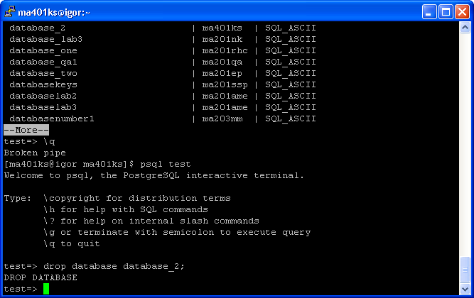

- Create a table — referred to as Table1 — preferably with a meaning in an application domain that you are accustomed with, with at least one column of each of the following types: character/string, integer, serial and date.

Commands:
Psql database_1
CREATE TABLE Table1
( idNum serial,
FirstName varchar(12),
LastName varchar(12),
Gender char,
Age integer,
Address varchar(40),
DateOfBirth date);

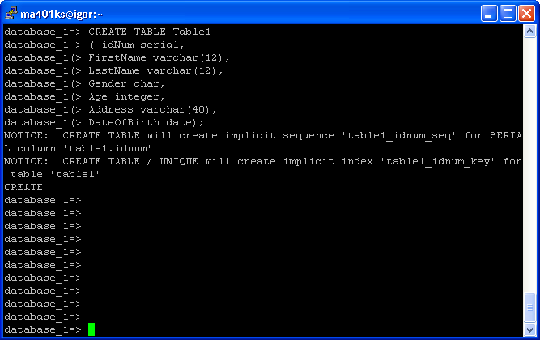

- Insert at least 15 rows in Table1, some of them having NULL values (not all the NULLs in the table should be in the same column).

Commands:
Psql database_1
INSERT INTO Table1 VALUES (1, “Fred”, “Smith”, “M”, 50, “New Cross Rd, London”, “09/11/1954”);
INSERT INTO Table1 VALUES (2, “Stan”, “Jones”, “M”, 30, “Goldsmith College, London”, “13/09/1974”);
INSERT INTO Table1 VALUES (3, “James”, “Kirk”, “M”, 60, “USS Enterprise”, “02/03/1944”);
INSERT INTO Table1 VALUES (4, “Nina”, “Simone”, “F”, 70, “Long Beach, USA”, “09/11/1934”);
INSERT INTO Table1 VALUES (5, “Jim”, “Bowen”, “M”, 50, “Bolton, UK”, “09/11/1954”);
INSERT INTO Table1 VALUES (6, “Lenny”, “Bennet”, “M”, 40, “Leeds, UK”, “09/11/1964”);
INSERT INTO Table1 VALUES (7, “Ruth”, “Madoc”, “F”, 50, “Brighton, UK”, “06/08/1954”);
INSERT INTO Table1 VALUES (8, “Linda”, “Barker”, “F”, 30, “Currys, UK”, “01/05/1974”);
INSERT INTO Table1 VALUES (9, “Ewan”, “Jones”, “M”, 20, “Nottingham, UK”, “09/11/1984”);
INSERT INTO Table1 VALUES (10, “Fred”, “Wikins”, “M”, 10, “Manchester, UK”, “21/10/1994”);
INSERT INTO Table1 VALUES (11, “Huggy”, “Bear”, “M”, 50, “New York, USA”, “19/05/1954”);
INSERT INTO Table1 VALUES (12, “Gloria”, “Estafan”, ”F”, 40, NULL, “21/10/1964”);
INSERT INTO Table1 VALUES (13, “Fred”, “Mercury”, NULL, 50, “London, UK”, “01/10/1954”);
INSERT INTO Table1 VALUES (14, “Britney”, NULL, ”F”, 20, NULL, “19/04/1984”);
INSERT INTO Table1 VALUES (15, NULL, NULL, NULL, 24, NULL, NULL);

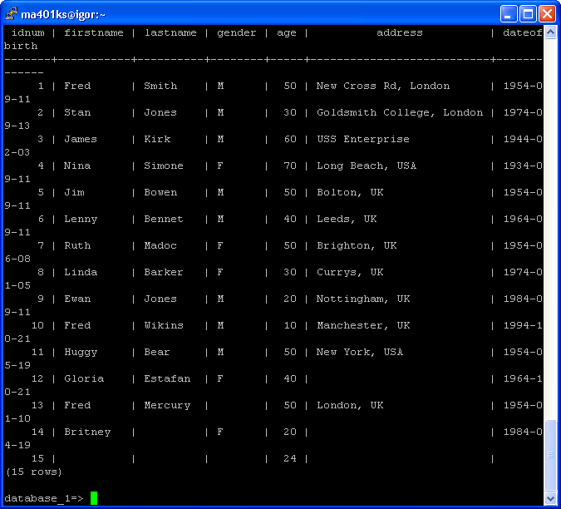

- Delete all the rows from Table1 having at least a NULL.

Commands:
DELETE FROM Table1
WHERE idNum = NULL OR
FirstName = NULL OR
LastName = NULL OR
Gender = NULL OR
Age = NULL OR
Address = NULL OR
DateOfBirth = NULL;
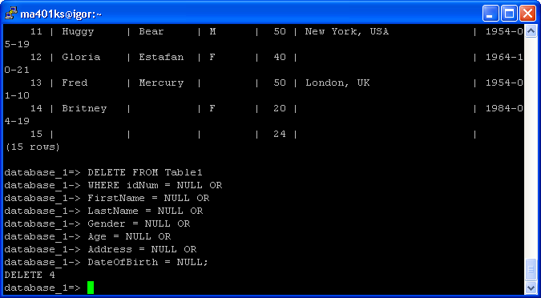

- Alter Table1 by renaming and adding new columns. Insert 10 rows in the table.

Commands:
ALTER TABLE Table1 RENAME COLUMN LastName to Surname;
ALTER TABLE Table1 ADD COLUMN ShoeSize integer;
ALTER TABLE Table1 ADD COLUMN HairColour varchar(10);
INSERT INTO Table1 VALUES (12, “Harry”, “Smith”, “M”, 50, “New Cross Rd, London”, “09/11/1954”, 10, “Brown”);
INSERT INTO Table1 VALUES (13, “Matt”, “Jones”, “M”, 30, “Goldsmith College, London”, “13/09/1974”, 12, “Blonde”);
INSERT INTO Table1 VALUES (14, “Robert”, “Smith”, “M”, 60, “USS Enterprise”, “02/03/1944”, 7, “Grey”);
INSERT INTO Table1 VALUES (15, “Tina”, “Simone”, “F”, 70, “Long Beach, USA”, “09/11/1934”, 5, “Grey”);
INSERT INTO Table1 VALUES (16, “Gary”, “Herbert”, “M”, 50, “Bolton, UK”, “09/11/1954”, 8, “Black”);
INSERT INTO Table1 VALUES (17, “Nobby”, “Bennet”, “M”, 40, “Leeds, UK”, “09/11/1964”, 9, “Red”);
INSERT INTO Table1 VALUES (18, “Rachael”, “Moore”, “F”, 50, “Brighton, UK”, “06/08/1954”, 4, “Purple”);
INSERT INTO Table1 VALUES (19, “Ronnie”, “Barker”, “F”, 30, “Currys, UK”, “01/05/1974”, 6, “Pink”);
INSERT INTO Table1 VALUES (20, “Eric”, “Jeffers”, “M”, 20, “Nottingham, UK”, “09/11/1984”, 8, “Ginger”);
INSERT INTO Table1 VALUES (21, “Johnny”, “Mullins”, “M”, 10, “Manchester, UK”, “21/10/1994”, 12, “Black”);

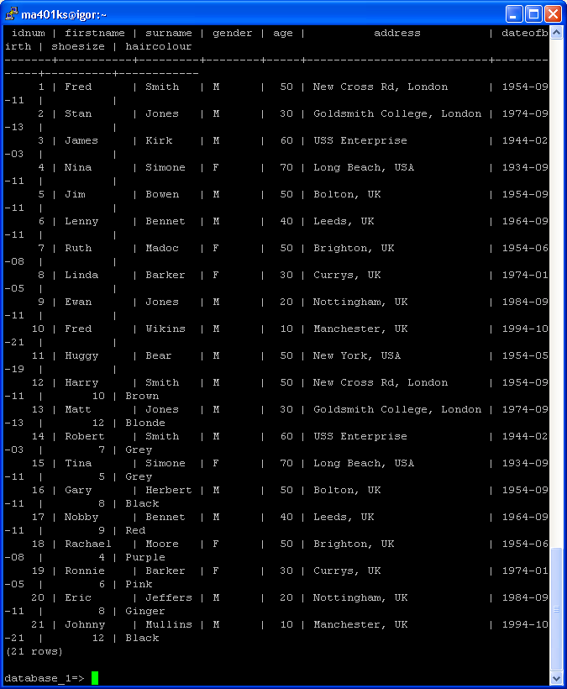

- Retrieve values from Table1 via 3 queries with the following specifications:
  - a restriction using a condition on a single field

Commands:
SELECT * FROM Table1 WHERE
AGE > 30;
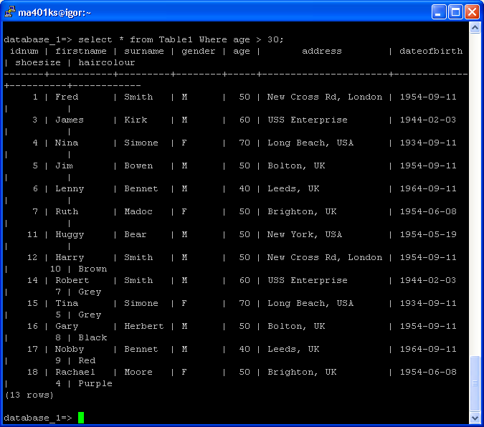

  - a restriction using a condition on two fields

Commands:
SELECT * FROM Table1 WHERE
AGE > 30 AND NOT Gender = “M”;

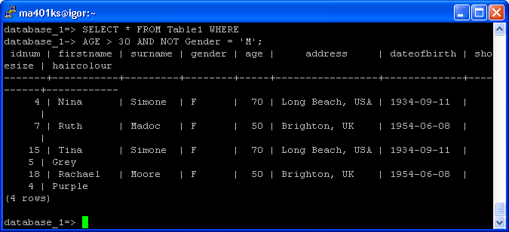

  - a projection and a restriction using a condition on three fields.

Commands:
SELECT Firstname, Address FROM Table1 WHERE
AGE > 30 AND (NOT Gender = ‘M’ OR address like ‘L%’);

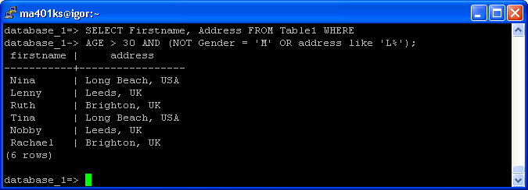

Use each of the logical operators NOT, AND, OR in at least one query.

- Copy the content of Table1 into a file.

Commands:
This requires supervisor rights

COPY Table1 TO ‘/mnt/moya/home/ugrad/ma401ks/File_table1’
USING DELIMITERS “,”;

Else use

\copy table1 to File_table1
pico File_table1

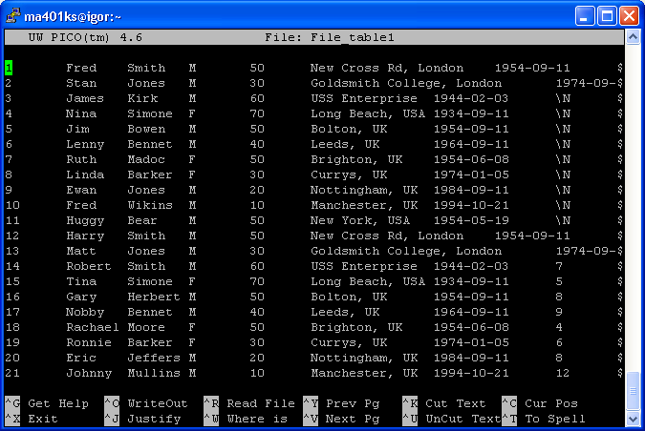

- Create a table named TableA with the same specifications as Table1, but with each field constrained in a way of your choice. All the constraints should differ from one another.

Commands:
CREATE TABLE TableA
( idNum serial ,
FirstName varchar(12) CHECK (NOT FirstName = NULL) ,
LastName varchar(12) CHECK ( NOT (Trim(LastName) = NULL )),
Gender char CHECK (Gender IN (‘M’, ‘F’)) ,
Age numeric CHECK (Age > 0) ,
Address varchar(40) UNIQUE ,
DateOfBirth date CHECK
(DateOfBirth BETWEEN ‘01/01/1900’ AND CURRENT_DATE) ,
PRIMARY KEY (idNum)
);

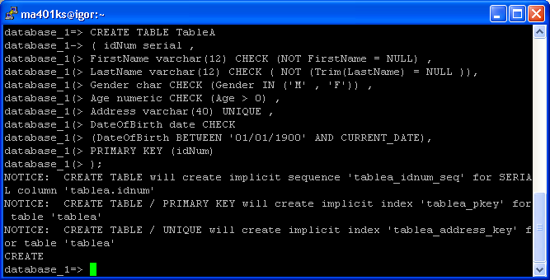

- Copy the values stored in the file you previously created using a text editor into TableA.

Commands:
This requires supervisor rights

COPY TableA FROM ‘/mnt/moya/home/ugrad/ma401ks/File_table1’;

Else use

\copy tablea from File_table1

- Create a table named Table3 with the following specifications:
  - It has fewer fields than Table2. Each field in Table3 has one and only one corresponding field in Table2; “corresponding”, here, means “of the same data type, but possibly of a different name”.

Commands:
CREATE TABLE Table3
(FirstName varchar(12),
Nationality varchar(10),
EyeColour varchar(8)
);

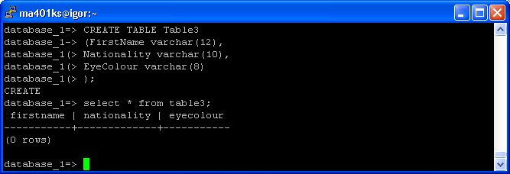

  - Insert values in Table3 from Table1 via a SELECT statement.

Commands:
INSERT INTO Table3 (FirstName) SELECT Table1.FirstName from Table1;

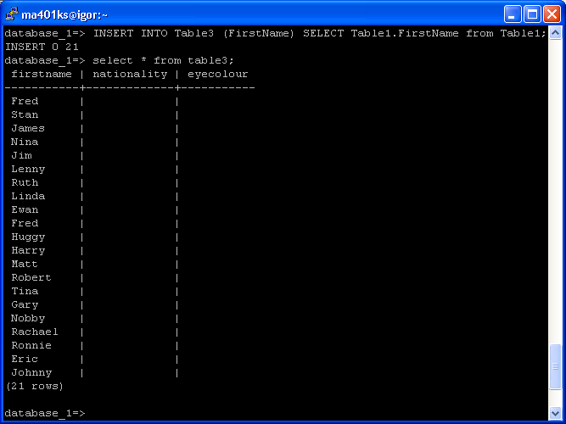

- Modify rows in Table3 via at least 5 different UPDATE statements.

Commands:
UPDATE Table3 SET Nationality = ‘British’ WHERE firstname LIKE ‘H%’ OR firstname LIKE ‘%y’;

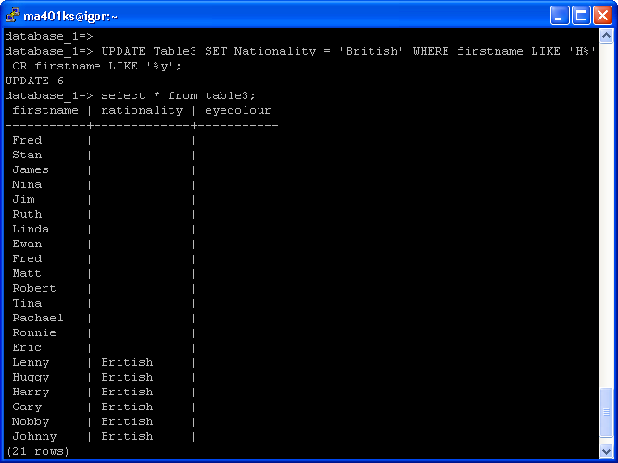

UPDATE Table3 SET nationality = ‘Irish’ WHERE (length(firstname) > 5) AND nationality = NULL;

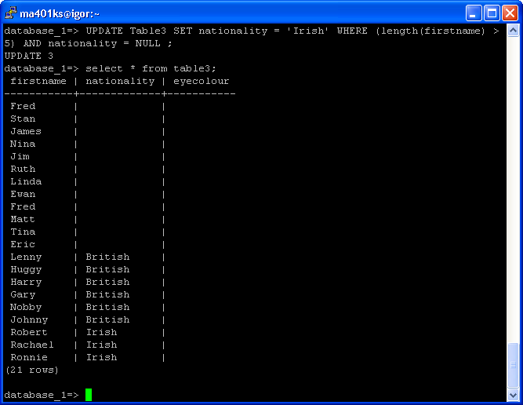

UPDATE Table3 SET nationality = “Finnish’ WHERE nationality = NULL;

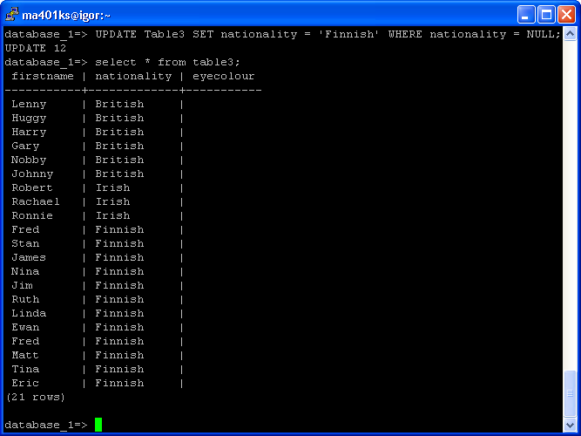

UPDATE Table3 SET eyecolour = ‘Blue’ WHERE nationality = ‘British’ OR firstname LIKE ‘%a%’;

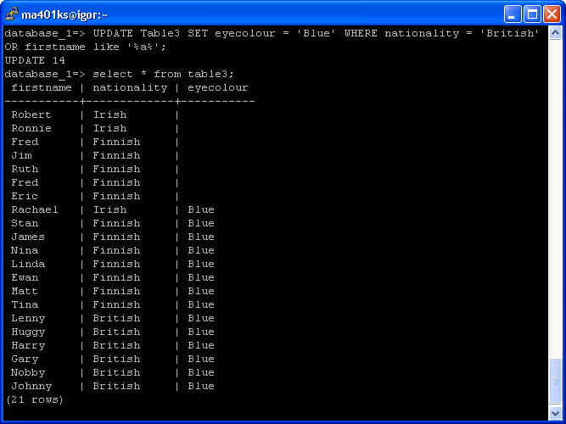

UPDATE Table3 SET eyecolour = ‘Green’ WHERE eyecolour = NULL AND firstname LIKE ‘%e%’;

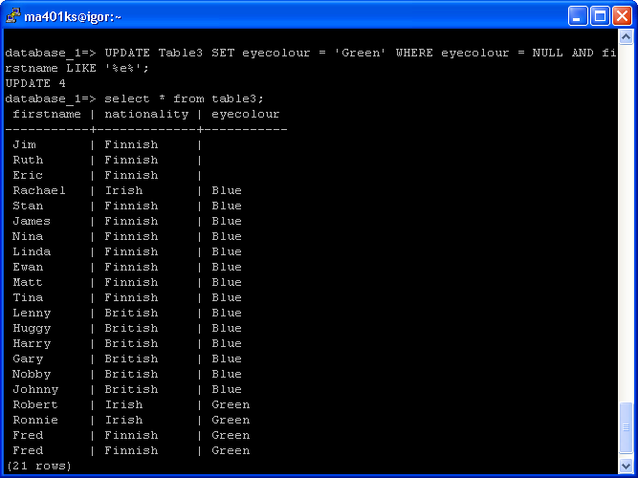

- Remove rows from Table3 via at least 3 different DELETE statements.

Commands:
DELETE FROM Table3 WHERE eyecolour = NULL;

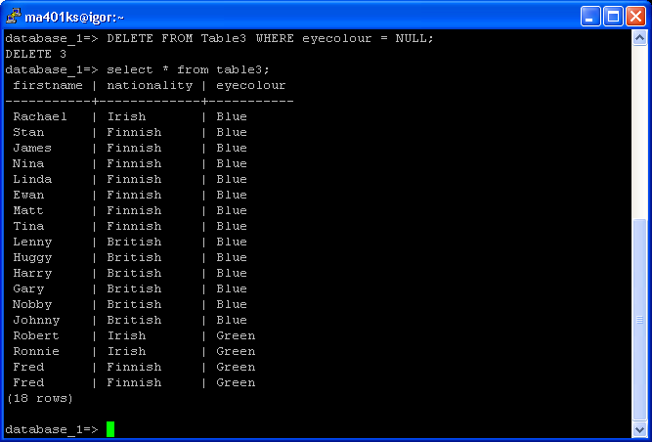

DELETE FROM Table3 WHERE eyecolour = ‘Blue’ AND firstname LIKE ‘H%’;

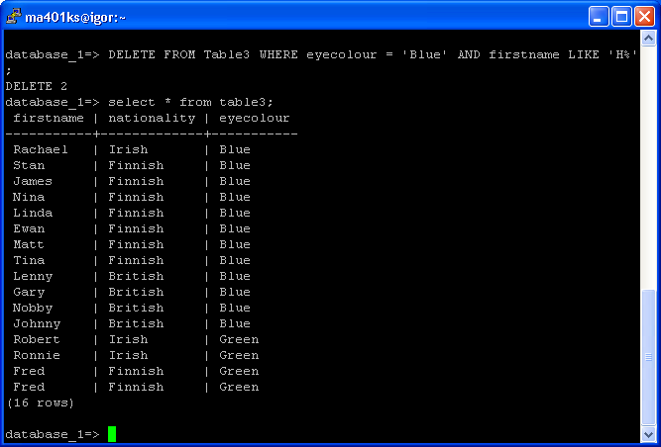

DELETE FROM Table3 WHERE eyecolour = ‘Blue’ AND nationality = ‘Finnish’;

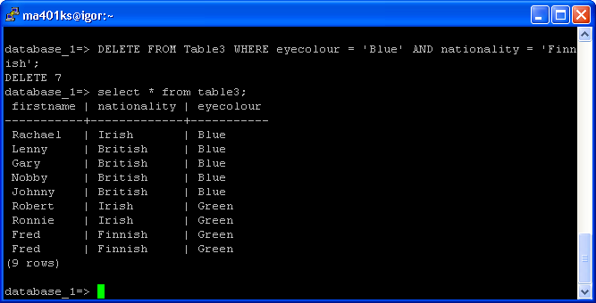

- Create two tables —Table4 and Table5 — exactly following the structure of Table3 and Table1 respectively.

Commands:
CREATE TABLE Table4 AS SELECT * FROM Table3 WHERE firstname = NULL;

Or

CREATE TABLE Table4 () INHERITS (Table3);

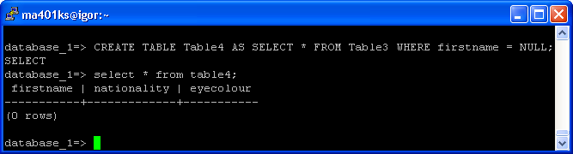

CREATE TABLE Table5 AS (SELECT * FROM Table1 WHERE Idnum = 0);

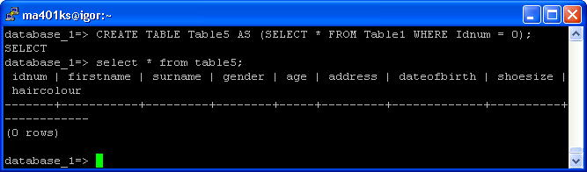

Move all the data from Table3 and Table1 in Table4 and Table5 respectively.

Commands:
INSERT INTO Table4 SELECT * FROM Table3;

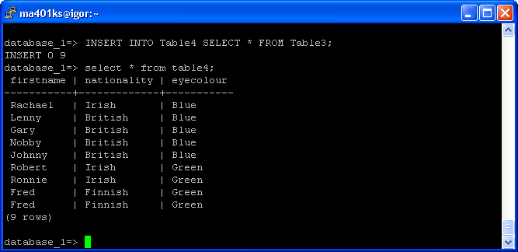

INSERT INTO Table5 SELECT * FROM Table1;

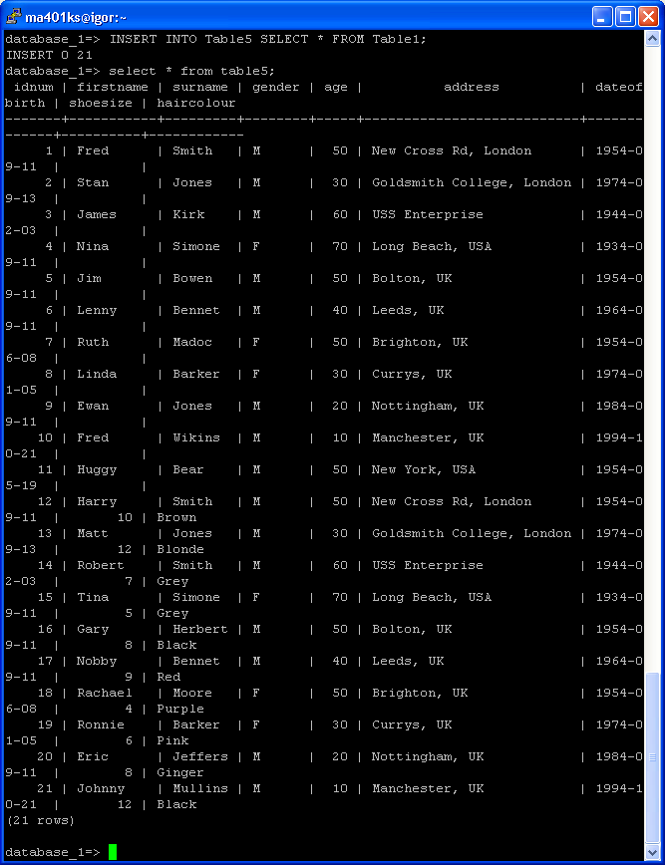

Then, remove Table2 and Table3.

Commands:
DROP TABLE TableA, Table3;

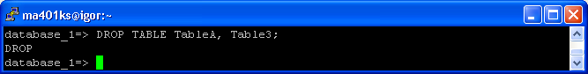

- Create a table – Table6 — with the same specification as Table5, but adding the constraint according to which Table6 cannot have more than 6 rows.

Commands:
CREATE TABLE Table6 (CONSTRAINT TooManyRows CHECK (NOT EXISTS (SELECT Count(*) FROM Table6 HAVING COUNT(*) > 7))) INHERITS Table1;

What happens if one tries to insert 7 rows, one by one, into this table?

Commands:
INSERT INTO Table1 VALUES (1, ‘Nina’, ‘Smith’, ‘F’, 25,’12 New Cross Road London’, 12021979);

It fails to add last row.

- List, using Postgres backend commands (backslash), the tables and their definitions, that you have currently in your database.

Commands:
\d

PART B - TASKS

Consider the following database (the sets of underlined attributes are primary keys).

Student(sid: integer, sname: string, programme: string, level: integer, age: integer)
Class(cname: string, meets_at: time, week_day: string, room: string, insid: integer)
Enrolled(sid: integer, cname: string)
Instructor(insid: integer, insname: string, deptid: integer)
Department(depid: integer, depname: string)

The meaning of these tables is straightforward; Student stores data about students registered in some programme offered by the university departments; Enrolled has one
record/row/tuple per studentclass pair such that the student is enrolled in the class. Instructor and Department store data about the instructors and their departments.

In what follows you are asked to create and populate the database and write some queries in SQL, providing the answers. No duplicates should be printed in any of the answers.

- Choose the foreign keys in the tables in a way you find appropriate. Then create the database and populate it in order to illustrate the following queries.

Commands:
Psql test
CREATE DATABASE Education_1;
Psql Education_1

CREATE TABLE Department
(deptid integer,
depname varchar(30) CHECK (NOT depname = NULL),
PRIMARY KEY (deptid)
);

CREATE TABLE Instructor
( insid integer,
isname varchar(20) CHECK ( NOT isname = NULL),
deptid integer,
PRIMARY KEY (insid),
FOREIGN KEY (deptid) REFERENCES Department
ON DELETE RESTRICT
ON UPDATE CASCADE
);

CREATE TABLE Class
(cname varchar(30),
meets_at time,
week_day varchar(9) CHECK (week_day IN(‘Monday’, ’Tuesday’, ’Wednesday’, ’Thursday’, ’Friday’)),
room varchar(25),
insid integer,
PRIMARY KEY(cname),
FOREIGN KEY(insid) REFERENCES Instructor
ON DELETE RESTRICT
ON UPDATE CASCADE
);

CREATE TABLE Enrolled
(sid integer,
cname varchar(30),
PRIMARY KEY(sid,cname),
FOREIGN KEY(cname) REFERENCES Class
ON DELETE RESTRICT
ON UPDATE CASCADE
);

CREATE TABLE Student
(sid integer,
sname varchar(20) CHECK (NOT sname = NULL),
programme varchar(25),
level integer CHECK (level > 0),
age integer CHECK (age > 0),
PRIMARY KEY(sid),
FOREIGN KEY(sid) REFERENCES Enrolled
ON DELETE RESTRICT
ON UPDATE CASCADE
);

INSERT INTO Department VALUES (5, ‘CS’);
INSERT INTO Department VALUES (6, ‘RS’);

INSERT INTO Instructor VALUES (1, ‘Johnson’, 5);
INSERT INTO Instructor VALUES (2, ‘Wilson’, 6);
INSERT INTO Instructor VALUES (3, ‘Smith’, 5);

INSERT INTO Class VALUES (‘Databases’, ‘11:00’, ‘Tuesday’, ‘Small Hall’, 1);
INSERT INTO Class VALUES (‘Java’, ‘10:00’, ‘Friday’, ‘Large Hall’, 2);
INSERT INTO Class VALUES (‘Databases 2’, ‘14:00’, ‘Tuesday’, ‘Medium Hall’, 3);
INSERT INTO Class VALUES (‘Java 2’, ‘15:00’, ‘Friday’, ‘Medium Hall’, 1);
INSERT INTO Class VALUES (‘VB .NET’, ‘10:00’, ‘Monday’, ‘Large Hall’, 1);

INSERT INTO Enrolled VALUES (10, ‘Databases’);
INSERT INTO Enrolled VALUES (11, ‘Databases’);
INSERT INTO Enrolled VALUES (12, ‘Databases’);
INSERT INTO Enrolled VALUES (13, ‘Databases’);
INSERT INTO Enrolled VALUES (14, ‘Databases’);
INSERT INTO Enrolled VALUES (20, ‘Java’);
INSERT INTO Enrolled VALUES (21, ‘Java’);
INSERT INTO Enrolled VALUES (22, ‘Java’);
INSERT INTO Enrolled VALUES (23, ‘Java’);
INSERT INTO Enrolled VALUES (24, ‘Java’);
INSERT INTO Enrolled VALUES (25, ‘Java’);
INSERT INTO Enrolled VALUES (26, ‘Java’);
INSERT INTO Enrolled VALUES (27, ‘Java’);
INSERT INTO Enrolled VALUES (28, ‘Java’);
INSERT INTO Enrolled VALUES (29, ‘Java’);
INSERT INTO Enrolled VALUES (10, ‘Databases 2’);
INSERT INTO Enrolled VALUES (11, ‘Databases 2’);
INSERT INTO Enrolled VALUES (12, ‘Databases 2’);
INSERT INTO Enrolled VALUES (20, ‘Java 2’);
INSERT INTO Enrolled VALUES (21, ‘Java 2’);
INSERT INTO Enrolled VALUES (22, ‘Java 2’);
INSERT INTO Enrolled VALUES (23, ‘Java 2’);
INSERT INTO Enrolled VALUES (24, ‘Java 2’);
INSERT INTO Enrolled VALUES (25, ‘VB .NET’);
INSERT INTO Enrolled VALUES (26, ‘VB .NET’);
INSERT INTO Enrolled VALUES (27, ‘VB .NET’);
INSERT INTO Enrolled VALUES (28, ‘VB .NET’);

INSERT INTO Student VALUES (10, ‘Harry Jones’, ‘CIS’ , 1, 19);
INSERT INTO Student VALUES (11, ‘Mary Jones’, ‘CIS’ , 1, 18);
INSERT INTO Student VALUES (12, ‘Jim Smith’, ‘CIS’ , 1, 21);
INSERT INTO Student VALUES (13, ‘Eric Frud’, ‘CIS’ , 1, 20);
INSERT INTO Student VALUES (14, ‘Francis Ray’, ‘CIS’ , 1, 17);
INSERT INTO Student VALUES (20, ‘Liz Hill’, ‘CRT’ , 2, 23);
INSERT INTO Student VALUES (21, ‘Ray Simons’, ‘CRT’ , 2, 21);
INSERT INTO Student VALUES (22, ‘Fred Harris’, ‘CRT’ , 2, 23);
INSERT INTO Student VALUES (23, ‘Angela Goya’, ‘CRT’ , 2, 18);
INSERT INTO Student VALUES (24, ‘Gary Stevens’, ‘CRT’ , 2, 19);
INSERT INTO Student VALUES (25, ‘Grit Breuer’, ‘CRT’ , 2, 32);
INSERT INTO Student VALUES (26, ‘Ben Norman’, ‘CRT’ , 2, 24);
INSERT INTO Student VALUES (27, ‘Harry Redknapp’, ‘CRT’ , 2, 27);
INSERT INTO Student VALUES (28, ‘Norman Cook’, ‘CRT’ , 2, 21);
INSERT INTO Student VALUES (29, ‘Peter Piper’, ‘CRT’ , 2, 18);

- Find the names of all Juniors (level = 1) who are enrolled in a class taught by Johnson.

Commands:
SELECT DISTINCT student.sname FROM Student, Enrolled, Instructor WHERE Student.level = 1 AND Instructor.isname = ‘Johnson’;

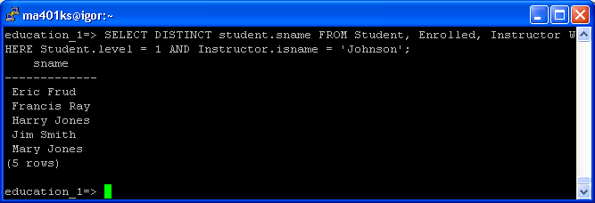

- Find the age of the oldest student who is in a CIS programme or is enrolled in a course taught by Wilson.

Commands:
SELECT MAX(age) FROM (SELECT age FROM Student, Instructor WHERE programme = ‘CIS’ OR Instructor.isname = ‘Wilson’) AS temp;

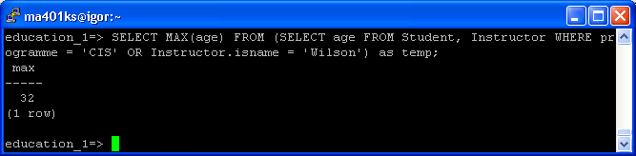

- Find the names of all classes that meet in the room Small Hall and have less than 50 students enrolled.

Commands:

SELECT distinct class.cname from class, (SELECT Enrolled.cname, count(cname) FROM Enrolled GROUP BY enrolled.cname HAVING COUNT(*) < 50) as temp where class.room = 'Small Hall';

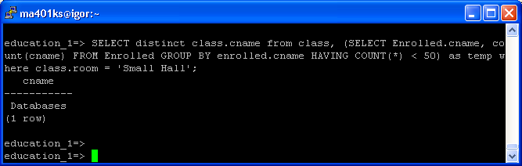

- Find the names of all CS students who have classes on Tuesdays in both the morning and the afternoon.

Commands:

(SELECT distinct student.sname FROM student, enrolled WHERE enrolled.sid = student.sid AND enrolled.cname =(SELECT class.cname FROM CLASS, Department WHERE Class.week_day = 'Tuesday' AND Department.depname = 'CS' AND (Class.meets_at BETWEEN '08:00' AND '11:59'))) INTERSECT
(SELECT distinct student.sname FROM student, enrolled WHERE enrolled.sid = student.sid AND enrolled.cname =(SELECT class.cname FROM CLASS, Department WHERE Class.week_day = 'Tuesday' AND Department.depname = 'CS' AND (Class.meets_at BETWEEN '12:00' AND '19:59')));

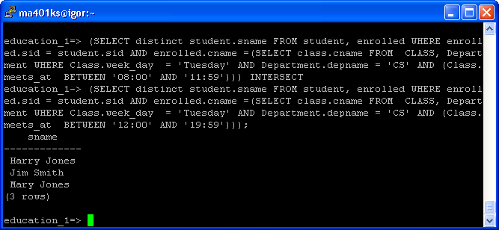

- Find the names of instructors who teach in every room in which some class is taught.

Commands:

SELECT instructor.isname FROM Instructor, (SELECT room, insid from class group by insid, room) as temp WHERE instructor.insid = temp.insid GROUP BY instructor.isname HAVING count(temp.insid) = (SELECT COUNT(DISTINCT room) AS mycount FROM Class);

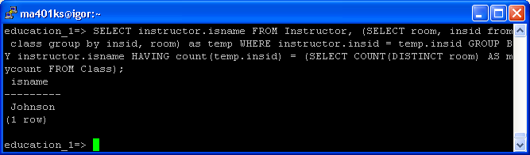

- Find the names of instructors for whom the combined enrolment of the classes that they teach is less than 6.

Commands:

Select instructor.isname FROM Instructor, class, (select distinct enrolled.cname, count(*) as mycount from enrolled group by enrolled.cname) AS temp WHERE class.cname = temp.cname AND instructor.insid = class.insid GROUP BY instructor.isname HAVING SUM(temp.mycount) < 6;

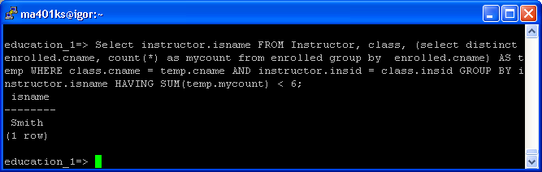

- List the level and the average age of students for that level, for each level.

Commands:

SELECT level, avg(age) FROM student GROUP BY level;

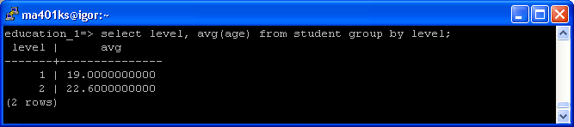

- List the level and the average age of students for that level, for all levels except level 1.

Commands:

SELECT level, avg(age) FROM student WHERE NOT Level = 1 GROUP BY level;

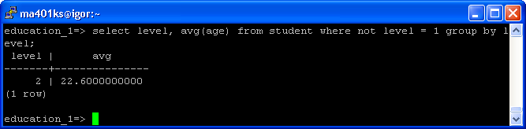

- Find the names of students who are enrolled in the maximum number of classes.

Commands:

SELECT student.sname FROM Student, (select distinct enrolled.sid, count(*) as mycount from enrolled group by enrolled.sid) as temp WHERE student.sid = temp.sid GROUP BY student.sname HAVING max(temp.mycount);

