Kester Sheridan (MSc Arts Computing)

Version 1

Arts Computing

Online Gallery - Report

Table of Contents
1. Introduction 3
2. Website 1 – ‘Nottenough’ 4
3. Website 2 – ‘Unicode’ 7
4. Bibliography 10

Introduction
In the course of this report I will make mention of two websites I have developed. The first is a simple online gallery showing some of my paintings and two flash movies that I have produced. The website is available for viewing at www.doc.gold.ac.uk/~ma401ks/website2/index.html. The second is a slightly more sophisticated website using Server side scripting (php) and a connection to a database so allowing dynamic content. This website is available at www.doc.gold.ac.uk/~ma401ks/unicode/index.html.
Jakob Nielsen in his book ‘Designing Web Usability’ attempts to pin down what makes a good website design to the acronym HOME-RUN:
- High-quality content
- Often updated
- Minimal download time
- Ease of use
- Relevant to users’ needs
- Unique to online medium
- Net-centric corporate culture
Although I would not claim that the two websites in this report cover all of these design issues, I have at least attempted to lay down the foundations of what might later become good design. I see website design like many other forms of design as an evolutionary process with an interplay between the designer and user over time. As these websites are merely prototypes one cannot necessarily judge them against Nielsen’s criteria.

Website 1 – ‘Nottenough’
This website is designed as an online portfolio of artworks I created as part of my final year whilst studying for a degree in Fine Art. The audience for this website is anybody who is interested in art and to whom I have sent my CV which includes the URL. Consequently it was important that the actual design of the website did not detract from the images on the site therefore it is relatively sparse in design. The name of the website comes from the fact that I lived in Nottingham for six years so I took the first four letters of this and added them to the word ‘enough’. I thought the name brought to mind style magazines such as ‘Sleazenation’ and implied some form of dissatisfaction and things not measuring up. I came up with the hook lines for site of ‘there is not enough my in your pocket’ and ‘there is not enough time in the day’ as I thought that most people could relate to these sentiments.
The website itself currently consists of two pages. The design is very traditional in terms of web design with a banner at the top with the name of the website and a horizontal menu system below this. The menu system is consistent on both pages and the selection changes colour to indicate that it is selectable.

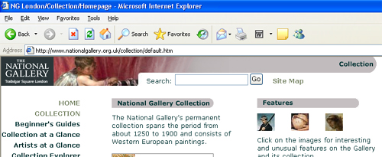

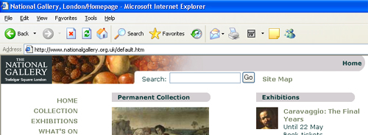
Figure 1: Two screenshots showing National Gallery website with different banners
I had originally thought of having a slightly different graphic header on each page similar to the National Gallery’s website (www.nationalgallery.org.uk) (see figure 1) with a section of a different painting on each page although still maintaining a consistent look. Consequently I designed the two images in figures 2 and 3. These are fairly mundane images, a ladybird children’s book and a highly reproduced Lichtenstein painting. However there has been some intervention in each image by someone with a red pen to join the two words ‘not’ and ‘enough’ by a big red ‘t’. However the dimensions of the images did not lend themselves well to the banner at the top, which is long and thin and so consequently I chose not to use them.

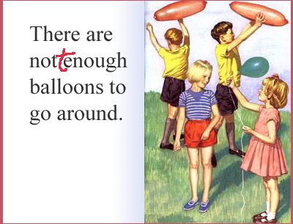
Figure 2: Adapted Children’s Ladybird book Figure 3: Adapted Roy Lichtenstein ‘In the Car’
The first page of the website includes two Flash movies that I created. I have included the phrase “but first a word from our sponsors”, to make reference to the fact the most websites have a lot of advertising on them. I had originally thought of having long thin advertising banners at the top of each page, which once clicked would bring up the flash advertisements. This would have been similar to many websites however I decided against this as users may well have ignored them like they do on other websites. The comment on advertising is an ironic gesture as each of the flash movies is in fact an advertisement for a spoof product or could be seen as advertising myself as the product. The Flash movies are episodic in nature as each one includes the same central character.
In the ‘Just for Bosses’ Flash movie (see figure 4) I was interested in lip-synching techniques and tried to match the characters’ lips to the voiceover. The movie makes reference to the cheesy adverts on TV for ‘Just for Men’ hair dye which in one shot shows a man with grey hair and next with dark hair and nobody else in the advert makes reference to it. There is also the more subtle and playful use of the images of Bruce Springsteen also known as ‘The Boss’ to illustrate the dye’s effect.

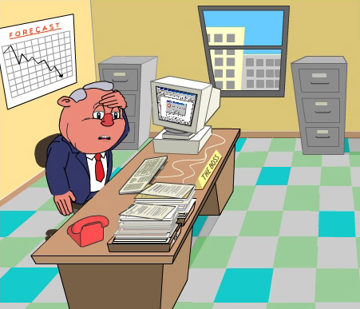
Figure 4: Scene from ‘Just for Bosses’ Flash movie Figure 5: Scene from ‘Headex’ Flash movie
The ‘Headex’ Flash movie (see figure 5) makes reference to the headache pill adverts that are seen on the TV. These adverts find increasingly unusual ways of showing a headache pill working on such an abstract thing as pain. I remember seeing one advert where they used the metaphor of an archer firing an arrow into a target so thereby ‘targeting pain’. In the movie I take this metaphor further by showing how much more effective my headache pill is by using a tank rather than an arrow. I also take a swipe at management by showing the boss character in the final scene spending his time in the office looking at pictures of scantily clad women. Technically I was interested in giving the characters a more convincing movement than in the previous movie.
The second page of the website is a gallery of thumbnail images. By clicking on one of these thumbnails, a larger version of the image is shown in a separate browser window with more details about the image shown alongside. This utilises the JavaScript function window.open( [sURL] [, sName] [, sFeatures] [, bReplace]) to open a separate window of constrained proportions. Once the image has been viewed, the user is then able to close this new window by either clicking on the x at the top of the window or by clicking on the ‘close window’ option on the window. Tool tips have been supplied to all the images on the website along with alternative text if the images do not load properly.
The website was designed with screen resolution 800 by 600. All the images are fixed width and height apart from the top banner, which is based on % to maintain the overall composition of the pages with the dark to lighter to dark traditions in background colour.

Website 2 – ‘Unicode’
This website is designed for the Goldsmiths’ Computer Arts Society. It has principally two functions, the first to act as a community website for the society where members can correspond with other members of the group through a notice board and forum, submit article, images and web links. The second is to act as an online portfolio and knowledge base in terms of submitted articles for anyone in the world interested in computer art. The name of the website is a play on words with ‘University’ and ‘code’. Unicode is the 16-bit character-encoding scheme allowing characters from all major world languages, living and dead, to be encoded into a single character set. As Goldsmiths is a fairly cosmopolitan university, one could liken the university hence the society to the Unicode encoding by bringing together different cultures and languages under one scheme.
It is hoped that as it is for an official University society then it might be able to take the internet address of www.unicode.gold.ac.uk, just like Wired, the University radio station has the website address of www.wired.gold.ac.uk. This would allow the site to be found easier on the worldwide web.
The two facets of the website are separated by a secure log on for the members of the society. Once logged in, members can delete, insert and update the content of the site so it effectively becomes a Content management system. This empowers each individual member allowing them to disseminate information at the click of a button and allowing them to personalise the content of the website. This allows for a much faster turnaround in publishing content compared to the model, which involves sending content and images to a web-master who in turn publishes the material on the Internet.
Technically this is achieved through the use of php, a server-side scripting language and a database connection to a mySQL database. The user is able log on to the website at any point throughout browsing the site by clicking on the login link. This opens a separate browser window using the JavaScript command, window.open( [sURL] [, sName] [, sFeatures] [, bReplace]). A connection is then made to the mySQL database via a php script to validate the user name and password, which is encrypted using sha1 encryption. If the username and/or password do not match the ones in the database then this logon window is cleared and user must re-enter their details. If they are found on the database then using the JavaScript command, window.opener.location.reload( true ), the website is dynamically reloaded before the logon window is automatically closed. This has the advantage of allowing the user to maintain looking at the same content of the website as they were before they logged in. Once logged in the user is currently able to insert images and articles but should be able to delete and update these items as well as being able to insert, delete and update external web links and notices.
This empowering of the members of the society is extended further by allowing them to develop the overall design of the website through the implementation of Cascading style sheets. Similar to the CSS Zen Garden website (www.csszengarden.com) (see figure 6 and 7), through the implementation of external Cascading Style sheets, the design of the web page can be radically altered by changing the CSS but without changing the underlying HTML code. In the example of the CSS Zen Garden website only one page is altered and the user must choose the underlying CSS, to make this a more democratic process on the Unicode website a random number is generated on the splash screen before the user clicks to enter the website itself. This random number is in the range, which corresponds directly to a series of individual CSS file (each given the format sheetn.css where n is a number). This number is written to a cookie via JavaScript to allow this style sheet to be used for the duration of user’s visit to the website. The cookie expiry date is set for that day so each day the user will potential be confronted by a different design of the website, or may choose to change the design by re-entering the splash screen so rewriting the cookie. By this means there is a consistency in the website in terms of formatting and layout, and in terms of the navigation. The navigation adheres to web standards by having ‘Home’ at the beginning.

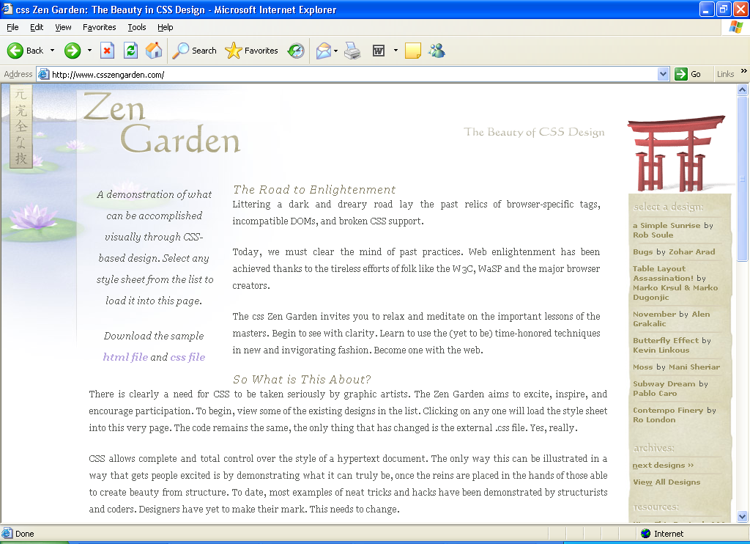
Figure 6: CSS Zen Garden website – the layout is controlled purely by CSS

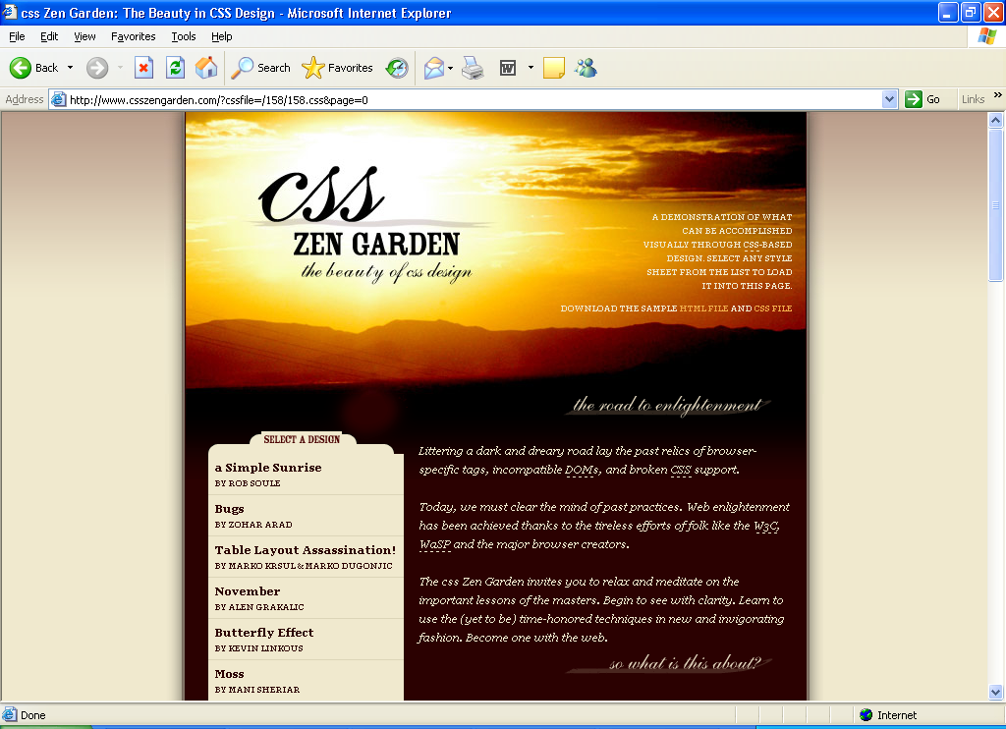
Figure 7: CSS Zen Garden website – same site, different Cascading Style Sheet

I have used a third-party HTML text area for the page where members are allowed to submit articles as this gives the user much more flexibility in terms of text formatting (allowing tables etc) than the standard HTML text area. As this part of the website grows, it maybe useful to have a search tool to allow users to search submitted articles for key phrases and topics. Equally it maybe worth including abstracts from each of the articles when browsing the articles, as the titles alone are not enough to determine the content of the article.
The Links section of the website which has yet to implemented will be separated into on-screen categories, for instance artists’ websites, festivals, technical etc. Thereby the user will have to choose a category from a drop down list of categories taken from the database by which their link will be submitted under. This will aid the use of this particular part of the website and it will act like a portal allowing people to find the relevant link.
I have been careful to make sure the JavaScript and the other client-side code is cross-platform and cross browser compatible. This has been particular evident in the implementation of the script which allows users to browse a series of images in the gallery by clicking on ‘back’ and ‘forward’ buttons. The JavaScript code, document.all.tags('name') is not supported in Mozilla Firefox 0.93 nor Safari 1.2.4 on the MAC OS X although works in Microsoft Internet Explorer 5.5 or higher, therefore I used document.getElementById(“name”), which is supported seemingly on all platforms. As the Image gallery is extended then it maybe worth restricting the size of the images that can be submitted or reducing their size automatically in the server-side scripting as otherwise there will be a considerable download time for this page.
As I have said previously the design allows for members of the society to design their own CSS to change the look of the website, however there may still need to be some form of vetting on these style sheets to maintain the usability of the website. This could allow for such design consideration as screen resolution and making sure that each design has the global navigation at the top of the screen and the breadcrumb trail to the side so adhering to web standards.

Bibliography
‘Content Critical – Gaining competitive advantage through high-quality web content’, Gerry McGovern & Rob Norton, 2002, Prentice Hall
‘Designing Web Usability’, Jakob Nielsen, 2000, New Riders

Technical Specifications
Selected SQL Statements

CREATE TABLE gallery (
id INT(4) NOT NULL AUTO_INCREMENT PRIMARY KEY,
description CHAR(200),
author CHAR(30),
title CHAR(70),
filepath CHAR(100)
);

CREATE TABLE articles (
id INT(4) NOT NULL AUTO_INCREMENT PRIMARY KEY,
title CHAR(50),
author CHAR(30),
body MEDIUMTEXT,
posted DATE
);

Selected JavaScript Functions

This is the code used for image browsing
function slideshowadv() {
var documentDivs = new Array();
for (var i = 0; i < highestZ; i++) {
documentDivs[i] = document.getElementById('layer' + i)
}
for (var i = 1; i < documentDivs.length; i++) {
var zIndex = documentDivs[i].style.zIndex;
if (zIndex == highestZ) {
documentDivs[i].style.zIndex = 1;
} else
documentDivs[i].style.zIndex = ++zIndex;
}
}
function slideshowrev() {
var documentDivs = new Array();
for (var i = 0; i < highestZ; i++) {
documentDivs[i] = document.getElementById('layer' + i)
}
for (var i = 1; i < documentDivs.length; i++) {
var zIndex = documentDivs[i].style.zIndex;
if (zIndex == 1) {
documentDivs[i].style.zIndex = highestZ;
} else
documentDivs[i].style.zIndex = --zIndex;
}
}

Page 380-381, ‘Designing Web Usability’, Jakob Nielsen, (1999) New Riders

