Kester Sheridan (MSc Arts Computing)

Version 1

Arts Computing

The Appropriation of Computer Games through ‘Modding’ to make art

Table of Contents
1. Introduction 3
2. ‘Modding’ as an Art Form 5
3. Conclusion 15
4. Bibliography 16

Introduction
The video games industry is a huge multi-billion pound industry. In 2003, gamers across the world spent £10.1bn ($18.2bn) on their video game hobby. In the UK the games’ market increased by 100%, compared with a 30% rise in cinema takings and a 4.5% drop in music sales. In 2003, Britons spent £1,152m on games, more than ever before, and far more than on going to the cinema or renting videos or DVDs (see figure 1). Best-selling games such as the Grand Theft Auto series sell around a million copies in a year. Due to their high retail price of around £40, this brings in gross retail revenues approaching £50m. By comparison, the top selling album in 2003, Dido's ‘Life For Rent’, sold 1.2 million copies, generating £14m in gross revenues.
25 million consoles or handheld gaming devices were sold between 1995 and 2003. This amounts to one for every household in the UK. Over the same period, more than 280 million games were sold, enough for every home to own 11 titles each.

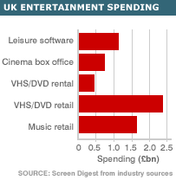
Figure 1: Graph showing UK Entertainment spending
However the risks are equally as high as the cost of creating games for consoles such as Sony PlayStation 2 (PS2) or Microsoft Xbox can now reach £10m ($18m). These development costs are only likely to increase further as ever more media rich games are demanded from the ranks of gamers and with the advent of new gaming consoles such as the PlayStation 3 and Xbox 2.
Gaming has truly become a mass-market entertainment format, comparable to any other mainstream activity. The Advertising industry has become wise to this fact with an increasing amount of advertising and product placements being seen in the games themselves. This is targeted at a captive audience of 18 to 35 year olds who are increasingly spending less time watching television and more time gaming. A quarter of US gamers have cut the time spent watching TV according to a recent survey. The influence of gaming is such that it has begun to influence other art forms. There have been a number of successful movie spin-offs such as the Tomb Raider films, and Street fighter. One is now able to buy the soundtrack to computer games such as for the Grand Theft Auto series just as one can buy the soundtrack to a popular film. Gaming has now entered the world of the gallery space with high profile exhibitions in recent years devoted to it such as the ‘Game On’ exhibition at the Barbican Art Gallery in 2002 and the ‘Game Show’ exhibition at the Massachusetts Museum of Contemporary Art in 2001-2002.

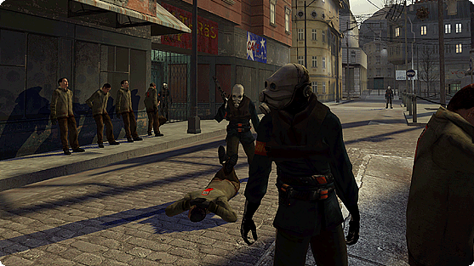
Figure 2: Screenshot taken from Half Life 2 (2004)
As games become more and more media rich such as Half-Life 2 (see figure 2) in which the gamer is able to immerse themselves in a fully interactive world, there is a greater attraction for the artist to utilise this technology for their own means. As the technology increases then for the artist the greater the meaning that can be communicated through this medium will be.

‘Modding’ as an Art Form
The History of Modding
The term "modding" is commonly used in reference to any sort of modification of a computer game from its officially released content by fans of that particular game. In this respect it is very similar to fans of TV shows or movies producing drawings, songs, videos and websites in homage to their favourite show or movie. Consequently the boundaries between the audience and producer become blurred. This is often referred to as a ‘Participatory Culture’.
The first instance of this phenomenon can be traced back to 1983 with ‘Castle Smurfenstein’, a ‘mod’ of the game ‘Castle Wolfenstein’, a classic arcade-style action game for the Apple II computer. In the ‘modded’ game, Smurfs replaced Nazi soldiers. This mixing up of popular culture became an enduring theme in the early years of the mod tradition.

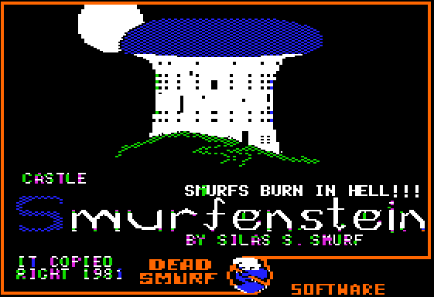
Figure 3: A screenshot taken from the mod, ‘Castle Smurfenstein’ (1983)
The first game to fully exploit the potential of user-created content was the hugely influential Doom (id Software 1993) (see Figure 4). Although Doom revolutionized computer gaming in more ways than one, one of its notable contributions was to give birth to the modding culture as we now know it. Instead of seeing modders as a sub-group of software pirates, id Software wholeheartedly encouraged fan production. Id's visionary programmer John Carmack held the "hacker ethic" close to heart, and designed the game specifically to be modifiable.
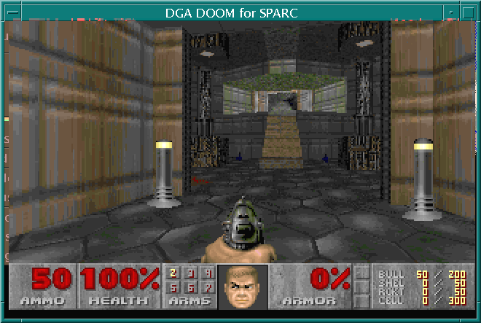
Figure 4: Screenshot from DOOM (1993)
The release of id's own follow-up Quake (1996), Valve Software's Half-Life (1998) and Epic Games' Unreal (1998) are land marks in the development of mod culture. These games were built on a much-advanced technology that allowed modders almost unlimited possibilities for innovation.
From the sub-cultural beginnings, the culture of modding has in the last decade entered the mainstream becoming one of the most distinctive features in current computer gaming culture thanks in large part to the rise of the Internet allowing communities of modders to share knowledge and projects, and the recognition by games publishers that this is an effective marketing strategy to increase their games longevity and popularity. Consequently fan production is supported through official editing tools bundled with the games (see Figure 5), source codes opened to the public, support forums and information resources hosted on the web, in-house workshops and seminars, and high-profile modding contests. It is equally seen by the PC Industry as means of training up the next generation of developers and will then hire directly from its ranks.

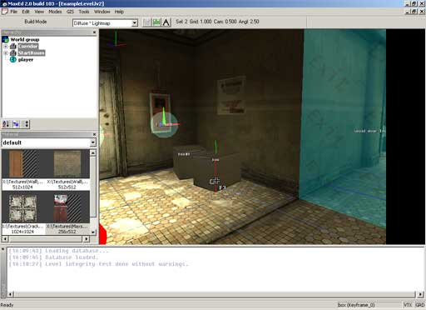
Figure 5: A Screenshot of MaxEd2, which is the editing tool for Max Payne 2
Recently, some of these mods have begun to rival the original games in popularity. Unarguably the biggest success story in the short history of modding has been Counter-Strike (2000), a multiplayer mod for Half-Life that became so popular with online gamers Valve Software eventually purchased the rights to distribute it commercially (see figure 6). The retail version of ‘Counter-Strike’ has sold over 1.5 million copies even though the mod has always been freely available for download.

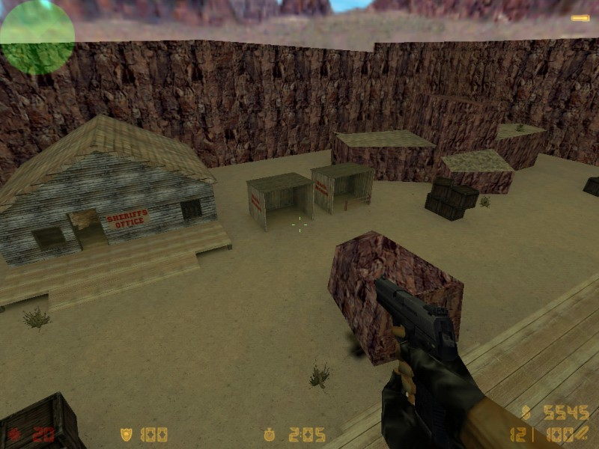
Figure 6: Screenshot from Counter Strike (2000)
These days it is almost expected that new computer game releases are modifiable. As the game technology grows more complex, modding will also become increasingly demanding. The more extensive mods are already often created by development teams with volunteers specializing in different aspects of modding - modelling, texturing, level design, sound design, programming etc. However it is still possible with the moderate outlay of buying the computer game and downloading the surplus of tools that are now available to allow someone with absolutely no programming experience to create meaningful changes to the gaming environment. This is may explain why there are a number of artists who now work on the fringes of this mod community either using pre-existing mods or creating their own.
The History of ‘Art Modding’
It is unclear when modding for the sake of producing something artistic began. Indeed one could argue that the earliest forms of modding such as ‘Castle Smurfstein’ and a mod of ‘Doom’ with Barney the Dinosaur could be seen with their recontextualisation of popular culture as a form of ‘Pop Art’. However if one is to see art as produced by artist and for a gallery environment then SOD (1999) must be seen as one of the first mods.

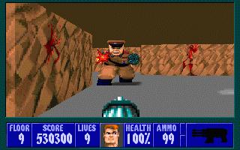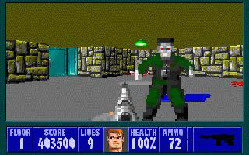
Figure 7a: Screenshots of the original Wolfstein 3D (1992)

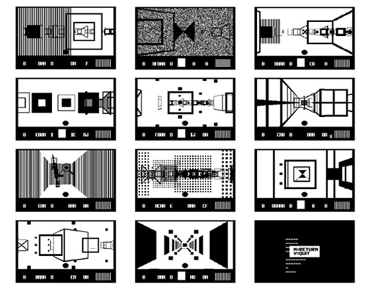
Figure 7b: SOD by Paesmans and Heemskerk (1999)
SOD was exhibited at the ‘Game Show’ exhibition at the Massachusetts Museum of Contemporary Art (June 2001 - May 2002). SOD is an extreme modification or "hack" of id Software’s action game Wolfenstein 3D (see Figure 7), in which the goal was to escape from a Nazi dungeon. In SOD, Wolfenstein 3D’s representational renderings (considered state-of-the art at the time of the game’s release in 1992) have been replaced by pure geometrical forms in a limited palette of black, white and grey. The result is a game space that is loosely architectural and extremely disorienting; it is easy to get lost, and it can be difficult to distinguish the walls from the targets one is supposed to shoot. Paesmans and Heemskerk complement the game-play difficulties with a cryptic interface and tongue-in-cheek game instructions along the lines of "If you are tough, press N. If not, press Y daintily." With its stark elegance, SOD offers a compelling alternative to the computer game industry’s mindless pursuit of representational realism. The limits of the technology at the time meant that the artwork was only really able to comment on the medium by which it had been created.
The abstract qualities of Paesmans and Heemskerk’s piece is in direct contrast to the realism of John Paul Bichard's recent artwork and illustrates the huge advances in computer game graphics over the period of five years. These artworks focus on the level of violence that is typical in a modern computer game. ‘The White Room’ (2004) (see Figure 8), is a set of photographic prints resulting from an in-game photo shoot that documents a series of constructed disasters. These interiors were set up by the artist using the videogame Max Payne 2, a 'Film Noir' thriller that tells a tale of lost love, deception and betrayal.
The photo shoot took place within the game's developer mode using cheats and a mod which increased the amount of blood, BenDMan'S 'bloody mod 1.2'. The game environment effectively becomes the photographer’s studio in which he is able to transform the objects and interiors by using the in-game weapons to 'paint' the sets with the blood of dead enemies.

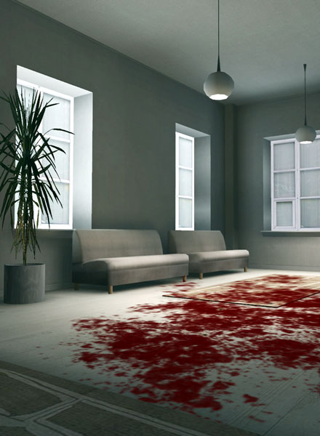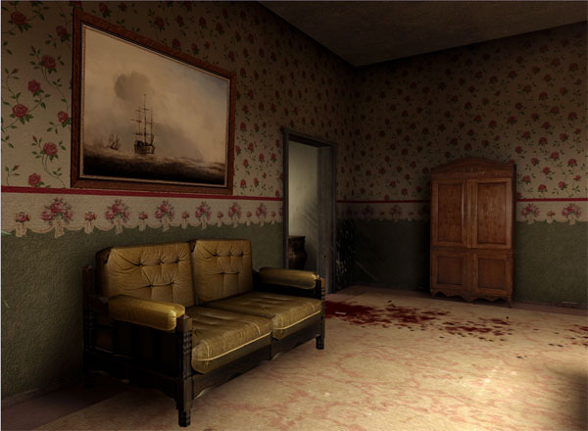
Figure 8: A Selection of Photos from ‘The White Room’ (2004),
Digital prints made from a Max Payne mod.
Bichard subverts this idea in Evidencia #000 (2004) making the real seem like a video game. Evidencia #000 (see figure 9) is a series of installations set up like a police forensic space depicting what remains after the level has been completed, marked out by striped tape as if it were a crime scene. This is a space in which everything has been frozen. The player has gone, leaving only the viewer as a voyeur, a witness.
Birchard describes this work as “the resultant sterile space, where every trace of activity, every fragment of debris is given potential significance, where scientists move in to analyse and de-construct the events, is in direct contrast to the First Person Shooter game space where players engage the tropes of massacre and destruction to advance through the level, leaving massive evidence trails with no apparent consequence. So what would happen if the game had consequences, what would happen to the remains?”

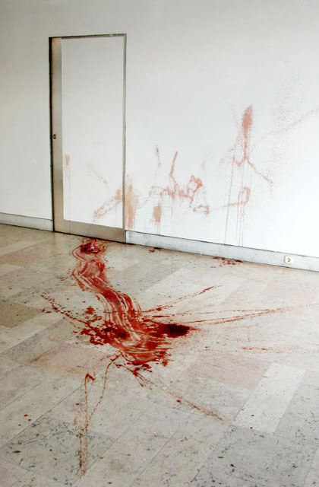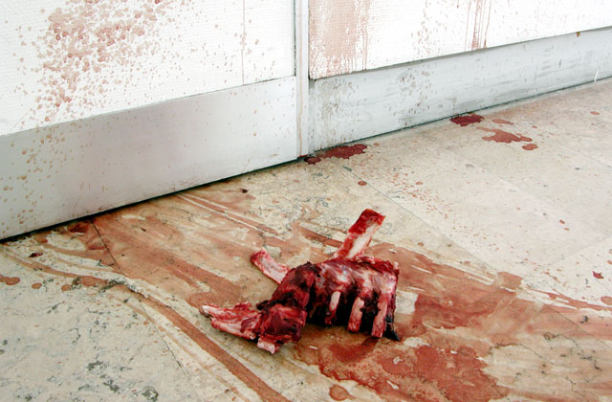
Figure 9: Scene from Evidencia#000 Installation – a Video game reconstruction
Computer games are undeniably associated with violence. This has found particular resonance with artists who have a socio-political or anti-war angle to their work. The associations of computer games such as shoot’em ups with mindless violence have made the mod an ideal medium for this type of art.
John Gerrard's digital work, ‘Slow Death’ (2003) (see Figure 10), shows a single figure falling to his death in the moment after having been shot. The figure, a soldier, moves in ultra-slow motion so that his physical demise occurs over a period of 20 days, a time that corresponds with the time of intense fighting in Iraq in August, 2003. The piece is developed from a mod of the game UNREAL TOURNAMENT in which the figure is recontextualised from the game environment to a stark featureless landscape. The drawing out of the figure’s death coupled with symbolic length of the piece adds poignancy to the work that can be seen as anti-war.
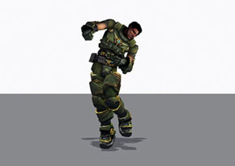

Figure 10: John Gerrard Slow Death (detail) 2003.
Twenty-two day long screen projection of real-time 3D model.

At the 2004 Biennial (March 11 to May 30) at the Whitney Museum of American Art in New York City, there was a big screen showing 'Velvet-Strike' (2002). It has also toured Europe, in art galleries and events like the 2004 Rotterdam Film Festival. It exploits a mod in the popular online game ‘Counter-Strike’ to allow players to spray ‘anti-war’ graffiti on the walls, ceiling, and floor of the game environment (see Figure 11). This is an online game intervention has been labelled as a protest mod. Velvet-Strike was conceptualized during the beginning of Bush’s "War on Terrorism." People are invited to submit their own "spray-paints" relating to this theme and so becomes another form of ‘Participatory Culture’. It was devised and created by Anne-Marie Schleiner, Brody Condon and Joan Leandre.

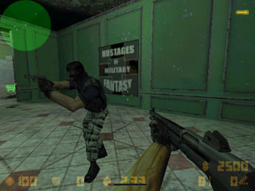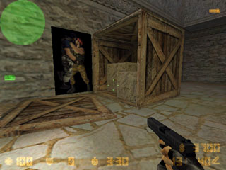
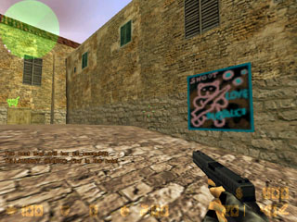
Figure 11: Screenshots from Counter-Strike with Sprays provided by Velvet-Strike (2003)
Its anti-war stance has struck a cord with people and seems increasing relevant as American casualties continue to mount in Iraq, and the gaming industry continues to jump on the military bandwagon. In the first days of the Iraq war, Sony copyrighted the phrase ‘shock and awe,’ for use in a (now abandoned) future video game. "America's Army," the game created as a P.R. and recruiting tool for the real U.S. Army, is now the number one online game according to CBS News. The online game Kuma\War (see Figure 12) is based on real-life events as they unfold in Iraq. Its website triumphantly states that you are able to play accurate re-creations of real war events weeks after they occur and carries a quote from an American soldier, “This game actually makes me flash back and think about the war and the aftermath…” as to its accuracy.
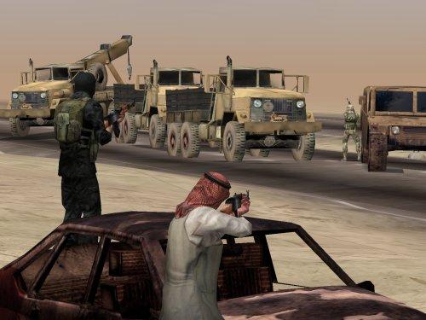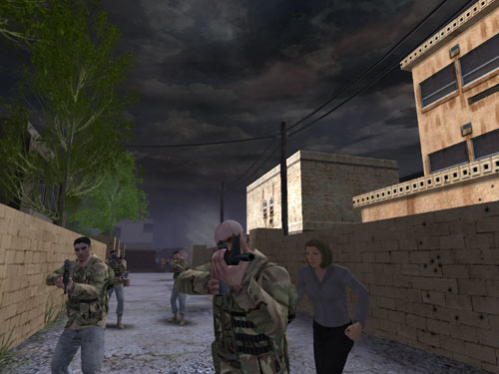
Figure 12: Screenshots from Kuma/War - Episodic online war game - ‘Accurate re-creations of real war events weeks after they occur.’ (2004)
Games like "Counter-Strike" create their own highly militarized, highly political world, and their creators pride themselves on the "realism" of the games. Protesters who deplore that reality and who go inside the game to deploy "Velvet-Strike's" graffiti are not welcome. "Velvet-Strikers" rely on the game to make their point. They leverage the existing design and popularity of the game to assist them in bringing their anti-militarism agenda into the game itself.
"Velvet-Strike" also takes a swipe at the underlying sexism of the macho gaming world with the "little-girl game" sprays, which throw hopscotch boards (see Figure 13) and pink teddy bears on the walls of "Counter-Strike's" otherwise immersive environment and sprays of two camouflage-covered soldiers poised for a kiss (see Figure 11 top right).
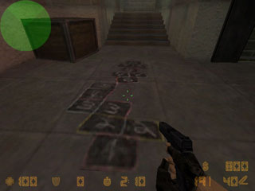
Figure 12: Hopscotch board by Velvet-Strike, spays for Counter-Strike (2003)

Just as “Kumar/War” (2004) uses real life information about the Iraq conflict to construct games realities, a similar strategy was employed by the developers of ‘Escape from Woomera’ (2004) (see Figure 13). Funded by the Australian Council for Arts, the project was to develop a mod of the game ‘Half-Life’ to model the Woomera Immigration Reception and Processing Centre in Australia. The detention centre, which has now closed, was established in 1999 to cope with a sudden influx of asylum seekers arriving illegally by boat to Australia but became notorious after a series of hunger strikes by the detainees with the aim of highlighting their plight. The game has a socio-political agenda highlighting the treatment of the refugees who were detained at this camp through an empathetic approach allowing the players of the game to experience the same but virtual treatment as the real detainees.

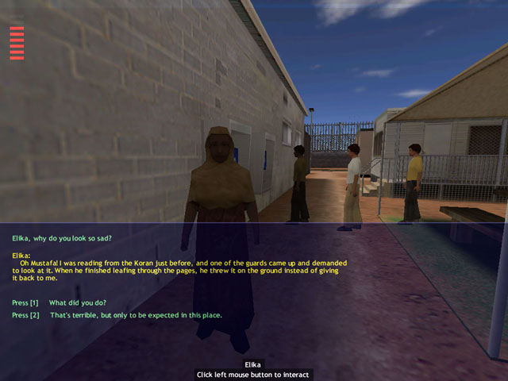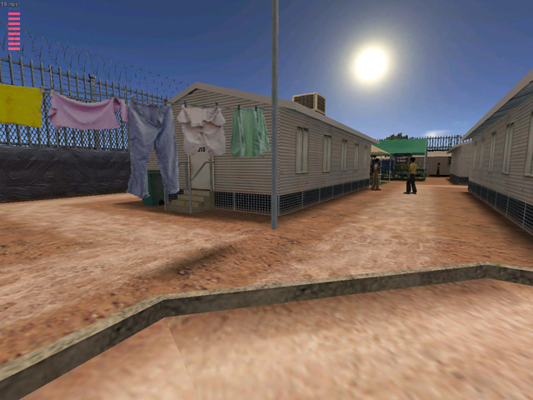
Figure 13: Screenshots from ‘Escape From Woomera’ (2004) – a mod of the game ‘Half-Life’
The game map is accurately modelled on the detention centre and is based on the reports of released detainees. ‘Escape From Woomera’ authentically recreates the conditions inside the camp. The player must attempt to break out, using techniques that have been employed by real detainees in the past. Clues and tools in the game provide opportunities for players to dig tunnels, scale fences, or appropriate the efforts of action groups and sympathetic lawyers. If clues are over looked, or if efforts come to futile ends, a player's hope degenerates until eventually they die of despair.
This idea of using art to document or highlight a tragedy or social injustice taps into a long tradition in art. Gericault’s ‘Raft of the Medusa’ is based on a real life tragedy that involved a ship wrecked at sea and its survivors. It has become a symbol of political injustice because the captain, who was appointed by Napoleon, abandoned the ship and left the 149 passengers on one small raft. Gericault researched this painting by interviewing survivors of this event therefore similar to ‘Escape From Woomera’ that was based on reports from detainees.

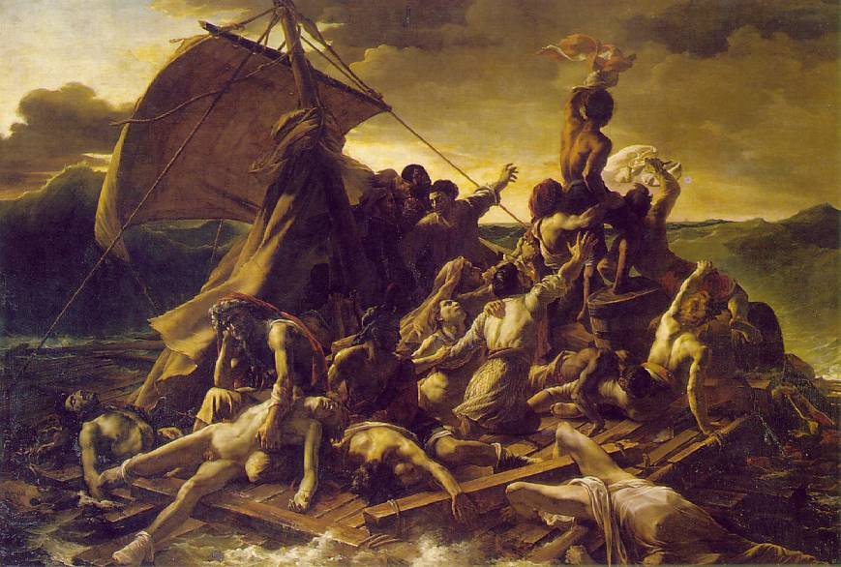
Figure 14: ‘Raft of the Medusa’, Theodore Gericault, (1819), oil on canvas, 16'x 23'6"
Possibly the most famous example of an ‘art mod’ is Ben Langlands & Nikki Bell’s collaboration with V/SpaceLAB, ‘The House of Osama bin Laden’ (2003) (see Figure 15) which was shown as part of the Turner Prize nominated exhibition of the same name at the Imperial War Museum, London (10th April 2003 – 26th May 2003). It is a mod of the game ‘Quake’ based on the digital photographs taken by the artists in a visit in October 2002 to a former home of Osama bin Laden at Daruntah, Afghanistan where he lived for a brief period in the late 1990s. The virtual model allows the observer to explore the house and surroundings. The model is presented in gallery setting on a big screen in front of a joystick controller mounted on a plinth. Although the joystick has a ‘fire button’ nothing happens when you press it unlike most computer games. The model is devoid of any discernable life. This coupled with the non-functioning ‘fire button’ make subtle reference to America’s inability to find Bin Laden given their military might. Unlike some of the other mods, it has no discernable end or beginning so although based on a game is not a game itself.

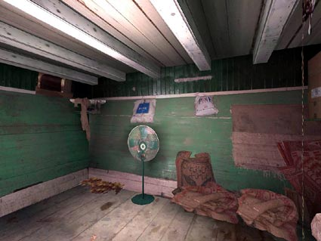

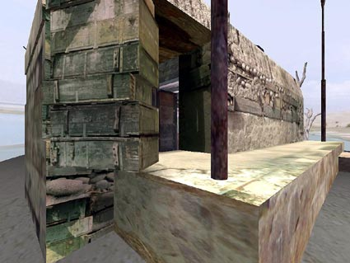
Figure 15: Screenshots from ‘The House of Osama bin Laden’, Langlands & Bell (2003)

Conclusion
The Game is the ultimate piece of art, capable of incorporating all forms of art and expression known to humanity, expressed using all forms of technology, from the ancient to the bleeding edge, without compromising its identity as a game. As technology increases and the computer world and reality begin to converge, then the sensorial experience of games will increase. The mod is the means of unlocking this technology but not necessarily possessing the key. It allows someone with a moderate appreciation of coding and the tools provided to do things quite complex to an existing game. It is true that if you wish to convert a game then this is quite a specialised skill and would require a number of people working in a project to achieve this. However a mod effectively allows the content to become more important than the means of getting there.
A number of artist have realised the potential of this new art form. This number is only likely to increase as gaming becomes more mainstream. No other artistic medium is constantly evolving as computers and computer games are. This is what makes it such an exciting medium to work with. As computers evolve, the stronger and more complex the message that the artist will be able to convey through it will be. No other medium can give such a visceral experience to the user as modern day computer games.

Bibliography
General
‘Past Exhibitions – Gameshow’, Massachusetts Museum of Contemporary Art website (http://www.massmoca.org/visual_arts/past_exhibitions/visual_arts_past_2001.html)
‘Games by Artists’, Select Parks, (http://www.selectparks.net/)
‘ALT + CTRL / A Festival of Independent and Alternative Games’, UCI Beall Center for Art & Technolgy, (http://beallcenter.uci.edu/exhibitions/altctrl.php)
‘Introduction to Max Payne 2 Tools and Modding’, Rockstar games (http://www.rockstargames.com/maxpayne2/mods/tutorials/index.html)
‘Introduction to computer game modding’, Games Research Labs, University of Tampere, Finland (http://www.uta.fi/hyper/projektit/mc2/research_intro.html)
‘Computer Game Modding, Intermediality and Participatory Culture’, Olli Sotamaa University of Tampere, Finland (2003) (http://www.imv.au.dk/eng/academic/pdf_files/Sotamaa.pdf)
‘Triumph of the mod’, Wagner James Au (2002) (http://archive.salon.com/tech/feature/2002/04/16/modding/)
‘Computer Game Technology Conference 2004’, CGT Promotions, (http://www.cgt.auc.ca/ppt/)
SOD Game
Artist website, Paesmans and Heemskerk, (http://sod.jodi.org)
John Paul Birchard
‘Staying to Play’, Hydropia website, (http://www.hydropia.org/evidencia03.htm)
‘The House in the Middle’, Hydropia website,(http://www.hydropia.org/middle04.htm)
John Gerrard
‘Terrorist Culture’, Regina Gleeson, The Sculptors' Society of Ireland (http://www.sculptors-society.ie/terrorculture.html)
‘Slow Death 2003’, (http://www.itwas.us/)
Escape From Woomera
‘Australian asylum protest spreads’ BBC News Online, 23rd January 2002 (http://news.bbc.co.uk/1/hi/world/asia-pacific/1776938.stm)
‘Analysis: Australia's tough asylum policy’ BBC News Online, 24th January, 2002, (http://news.bbc.co.uk/1/hi/world/asia-pacific/1780365.stm)
‘Escape from Woomera’, Project website (http://www.escapefromwoomera.org/index.html)
Velvet-Strike
‘Velvet-Strike - Counter Military Graffiti for CS’, Anne-Marie Schleiner, (http://www.opensorcery.net/velvet-strike/team.html)
‘The "Velvet-Strike" underground ‘,Jennifer Buckendorff, Salon (www.salon.com/tech/feature/2004/05/04/velvet_strike.html)
Langlands & Bell
‘Langlands and Bell The House of Osama bin Laden’, Online review CIRCA Art Magazine (http://www.recirca.com/reviews/langlandsandbell/index.shtml)
‘Langlands and Bell – Turner Prize 2004’, Tate Britain website (http://www.tate.org.uk/britain/turnerprize/langlandsbell.shtm)

Figures taken from BBC News Online, ‘UK turning into nation of gamers’, Alfred Hermida, 1st September 2004
Figures taken from BBC News Online, ‘UK turning into nation of gamers’, Alfred Hermida, 1st September 2004
Figures taken from BBC News Online, ‘Game start-ups revise strategies and hopes’, Alex Kleiderman, 20th October 2004
Taken from BBC News Online, ‘Ads in video games set to rise’, Jo Twist, 20th October 2004
Taken from ‘Introduction to Games Modding’, Games Research Lab, (http://www.uta.fi/hyper/projektit/mc2/research_intro.html)
Taken from ‘Introduction to Games Modding’, Games Research Lab, (http://www.uta.fi/hyper/projektit/mc2/research_intro.html)
Rhizome.org
Exhibited at the Towner Art Gallery, Eastbourne16th October - 5th December 2004 http://www.hydropia.org/middle04.htm
‘Staying into Play’ Quadrum Gallery Lisbon, One Person Show – Installation, Cabaret Voltaire 3 Festival 19th June - 30th July 2003 (http://www.hydropia.org/evidencia03.htm)
Quote taken from Kumar/War website (http://www.kumawar.com)
‘The Velvet-Strike underground’, Jennifer Buckendorff (www.Salon.com) May 4 2004
Quote taken from The Zero Game Studio, Sweden (http://zerogame.interactiveinstitute.se/art.htm)

